**🔸Programming in C – Lab Report**

**Experiment 1**

**Aim**

***To write a C program to print 'Hello World'.***

**Code**

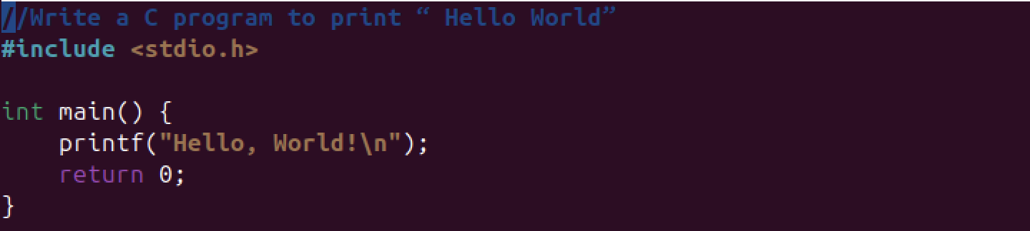

**Output**



**Explanation**

**Conclusion**

***Thus, the program was successfully executed.***

**Experiment 2**

**Aim**

***To print address in multiple lines using a single printf.***

**Code**

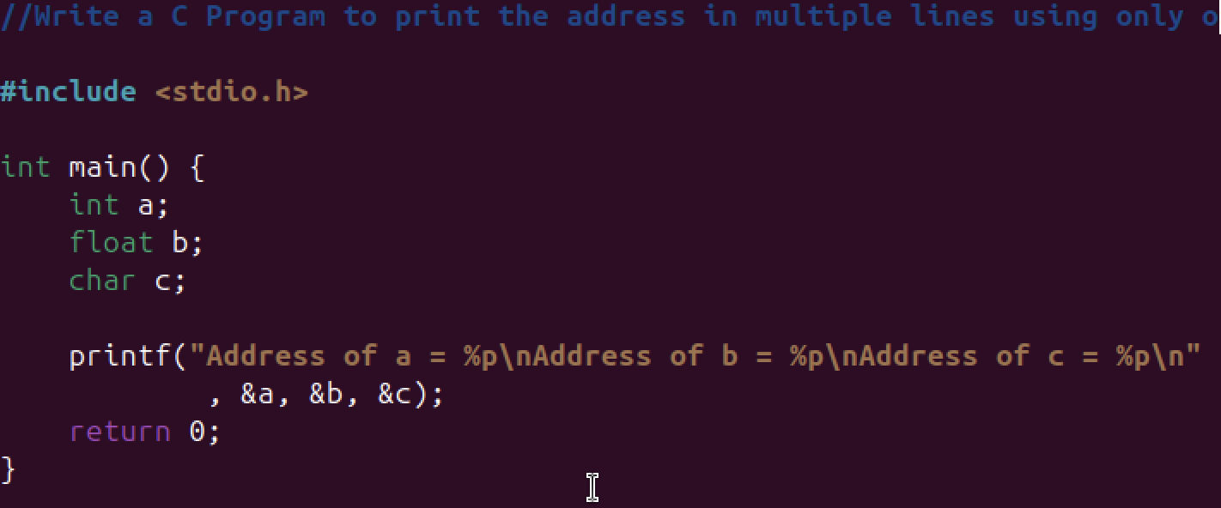

**Output**

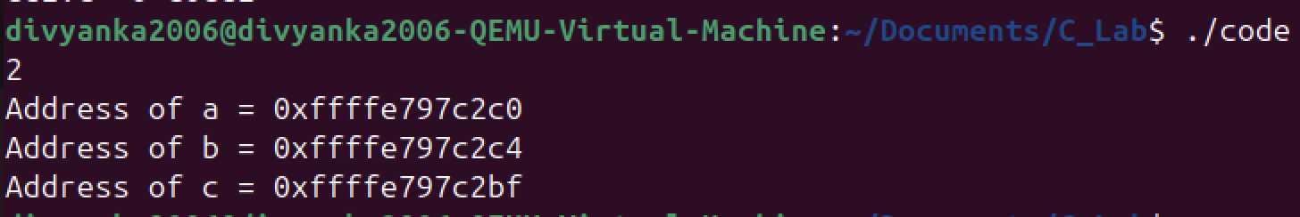

**Explanation**

**Conclusion**

***Thus, the program was successfully executed.***

**Experiment 3**

**Aim**

***To add two numbers entered by the user.***

**Code**

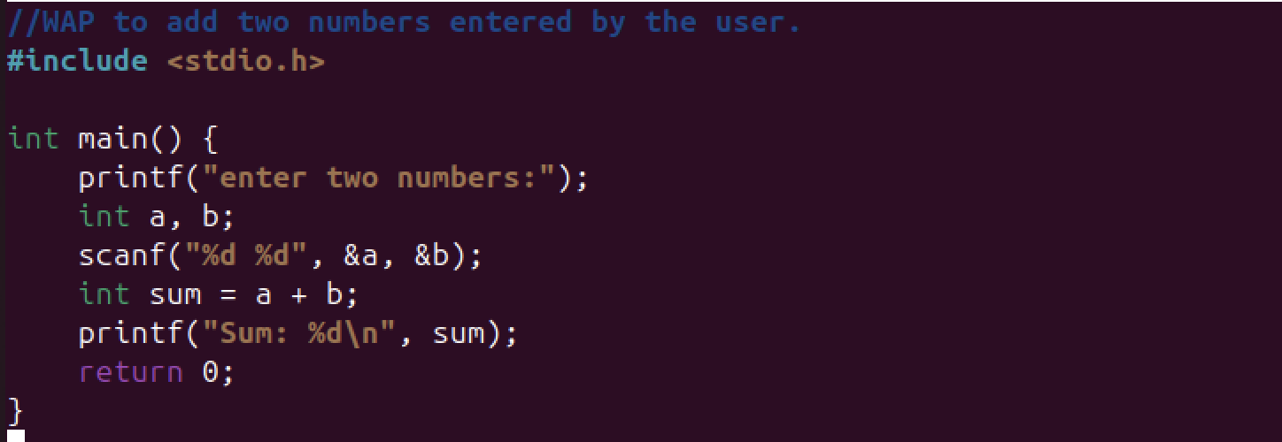

**Output**

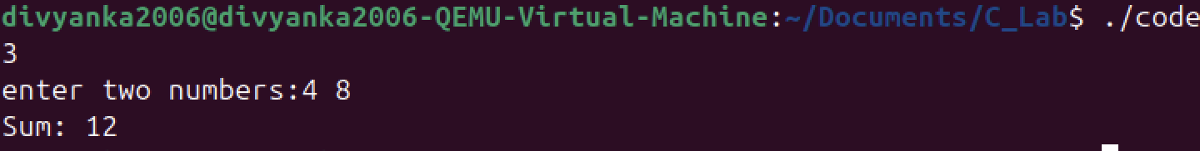

**Explanation**

**Conclusion**

***Thus, the program was successfully executed.***

**Experiment 4**

**Aim**

***To calculate the area and perimeter of a rectangle.***

**Code**

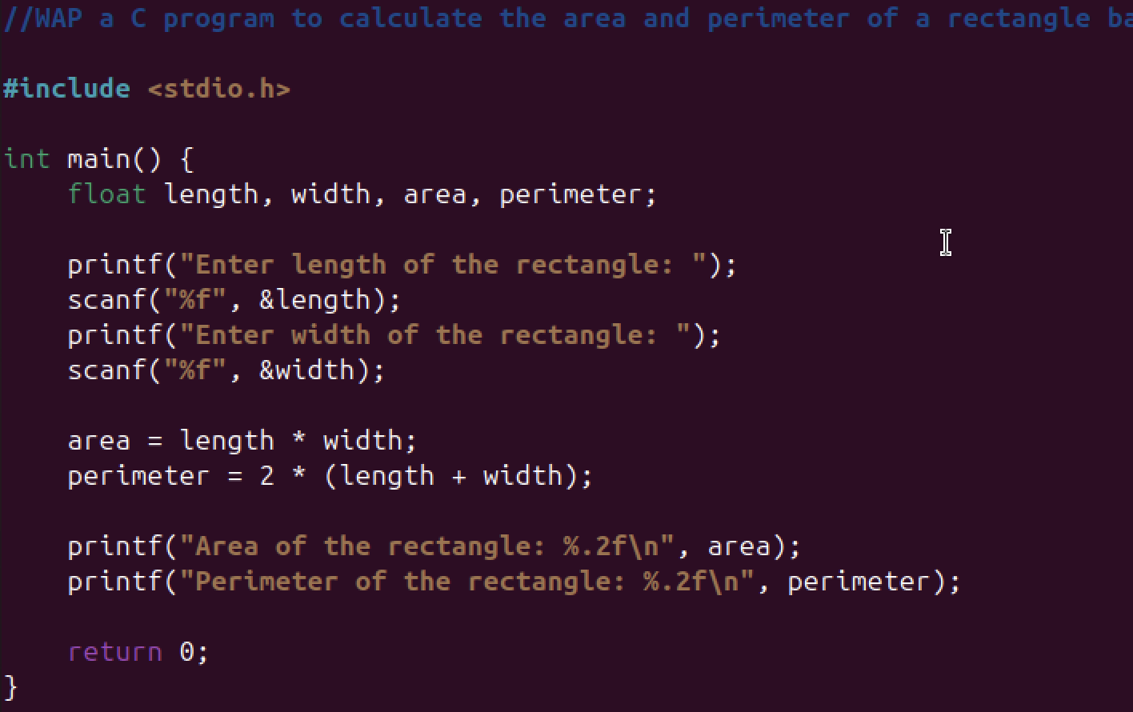

**Output**

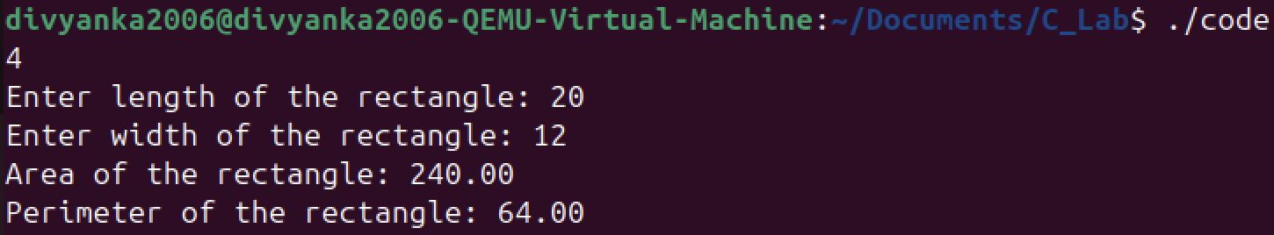

**Explanation**

**Conclusion**

***Thus, the program was successfully executed.***

**Experiment 5**

**Aim**

***To convert Celsius temperature to Fahrenheit.***

**Code**

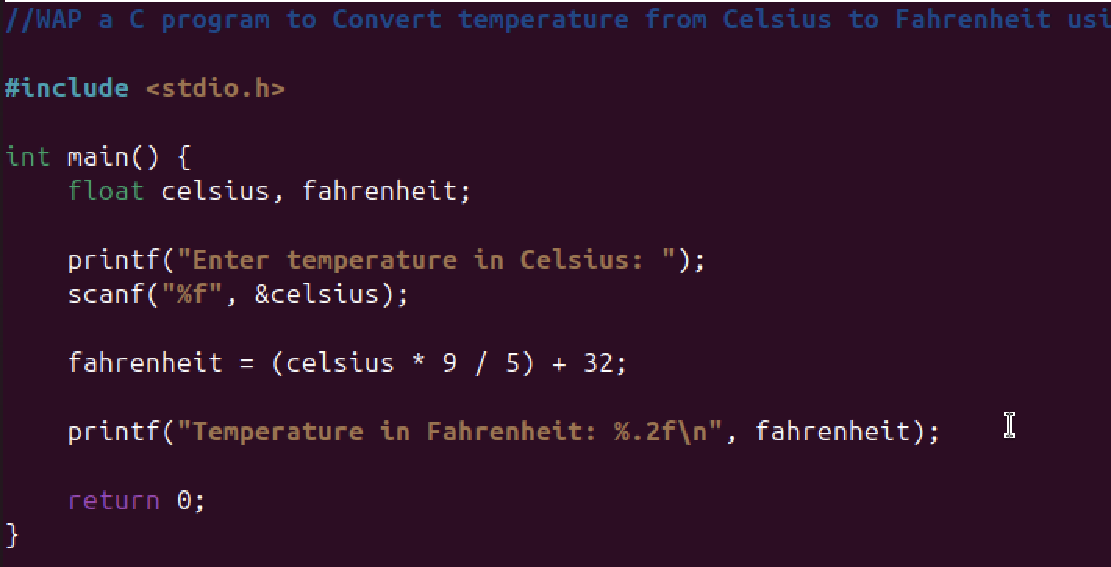

**Output**

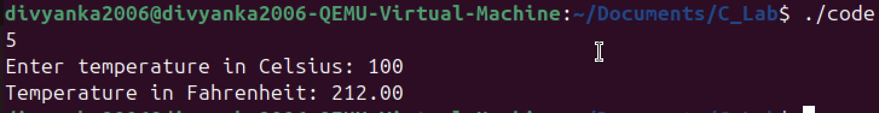

**Explanation**

**Conclusion**

***Thus, the program was successfully executed.***

**Experiment 6**

**Aim**

***The population of a town is 100000. The population has increased steadily at the rate of 10% per year for the last 10 years. Write a program to determine the population at the end of each year in the last decade.***

**Code**

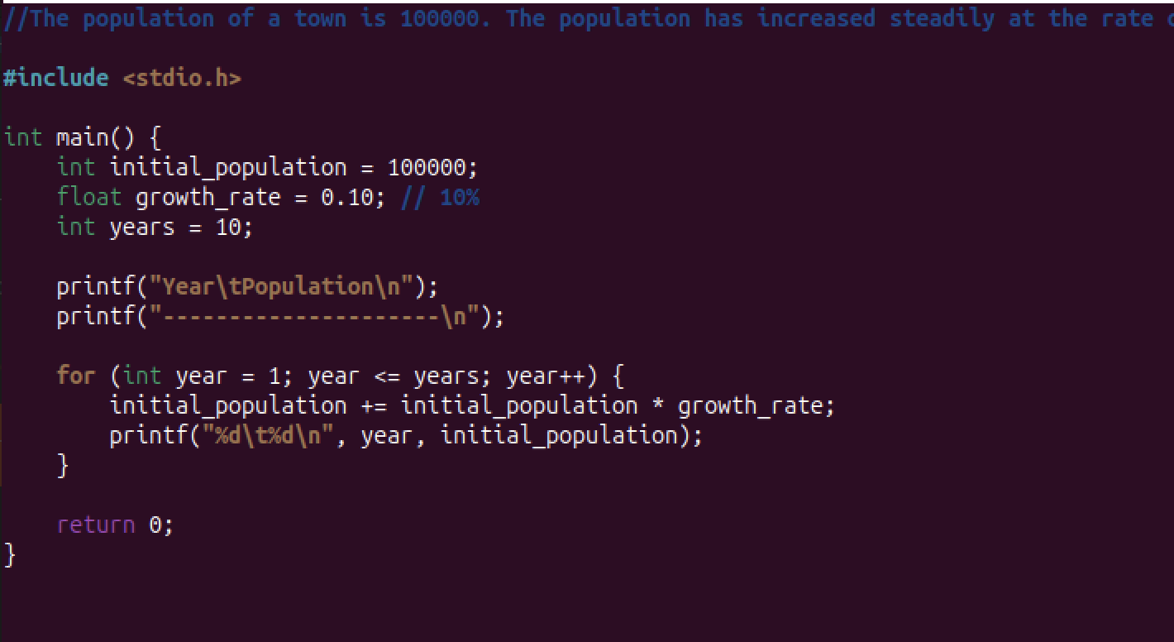

**Output**

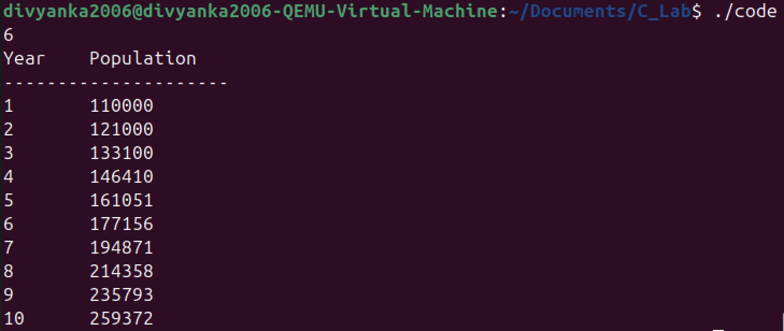

**Explanation**

**Conclusion**

***Thus, the program was successfully executed.***

**Experiment 7**

**Aim**

***Ramanujan Number is the smallest number that can be expressed as the sum of two cubes in two different ways. WAP to print all such numbers up to a reasonable limit. Example of Ramanujan number: 1729 12^3 + 1^3 and 10^3 + 9^3. for a number L=20(that is limit)***

**Code**

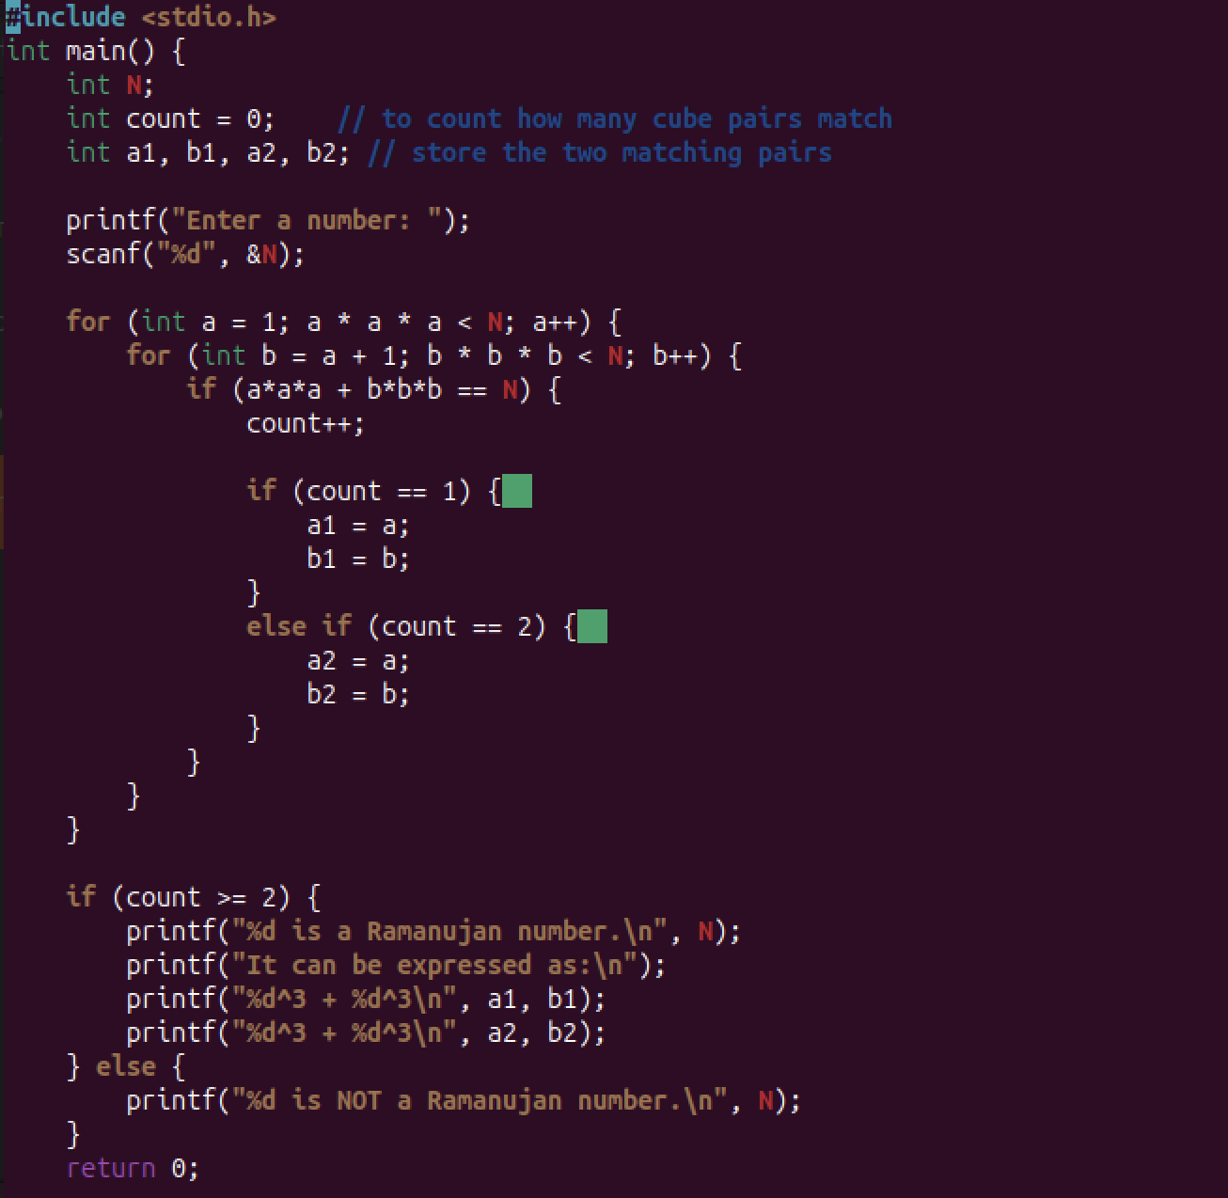

**Output**

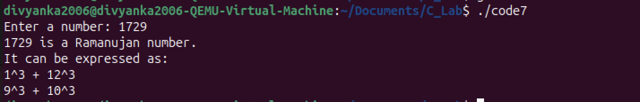

**Explanation**

**Conclusion**

***Thus, the program was successfully executed.***

**Experiment 8**

**Aim**

***Write a function which receives a float and an int from main( ), finds the product of these two and returns the product which is printed through main( ).***

**Code**

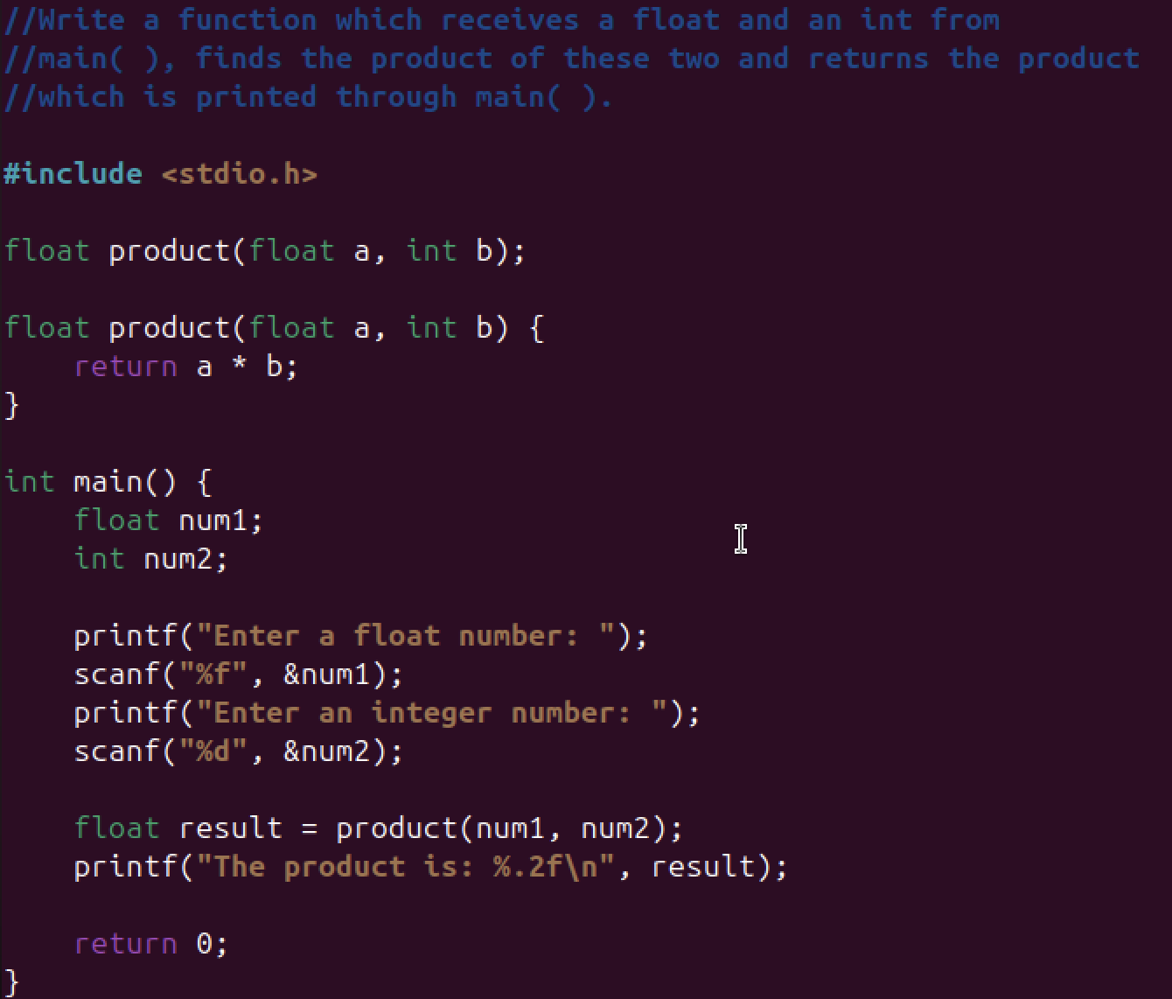

**Output**

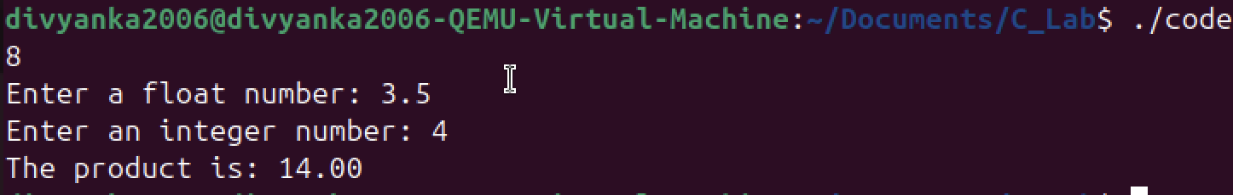

**Explanation**

**Conclusion**

***Thus, the program was successfully executed.***

**Experiment 9**

**Aim**

***Write a function that receives 5 integers and returns the sum, average and standard deviation of these numbers. Call this function from main( ) and print the results in main( ).***

**Code**

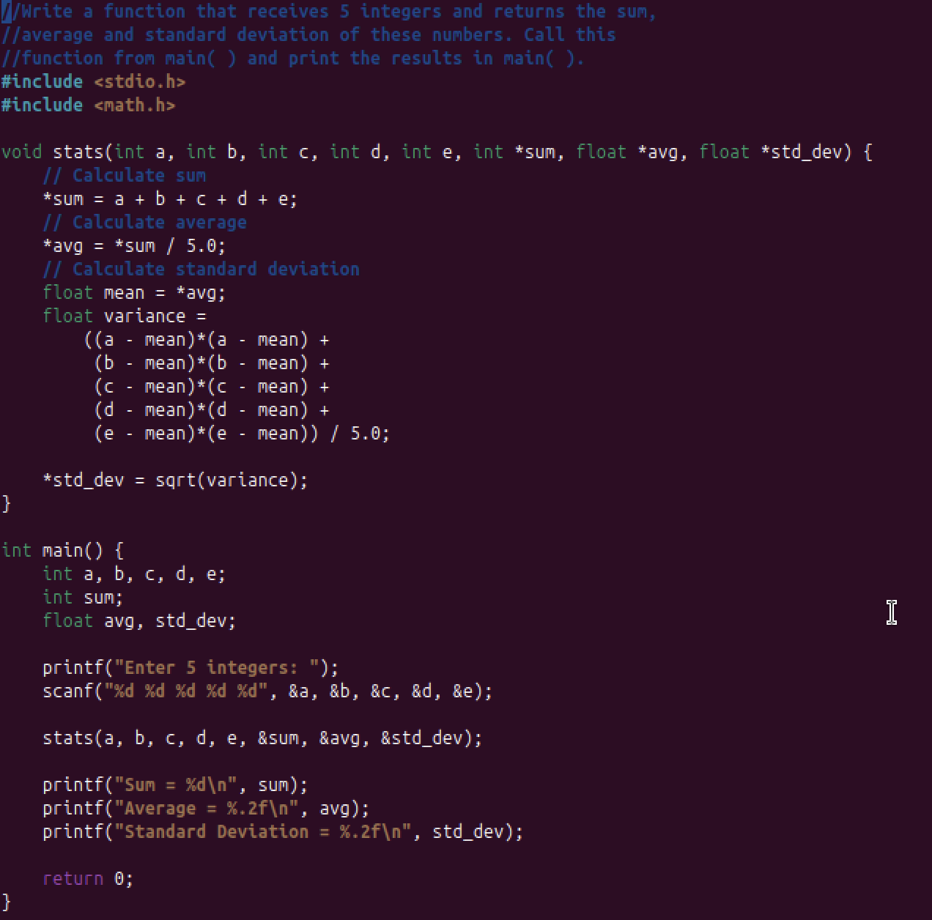

**Output**

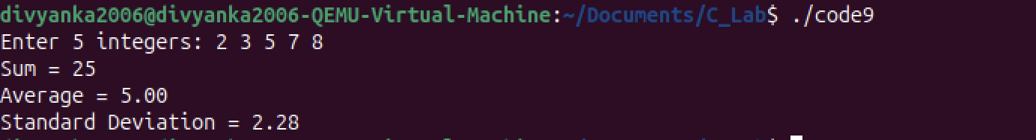

**Explanation**

**Conclusion**

***Thus, the program was successfully executed.***

**Experiment 10**

**Aim**

***Write a function that receives marks received by a student in 3 subjects and returns the average and percentage of these marks. Call this function from main( ) and print the results in main( ).***

**Code**

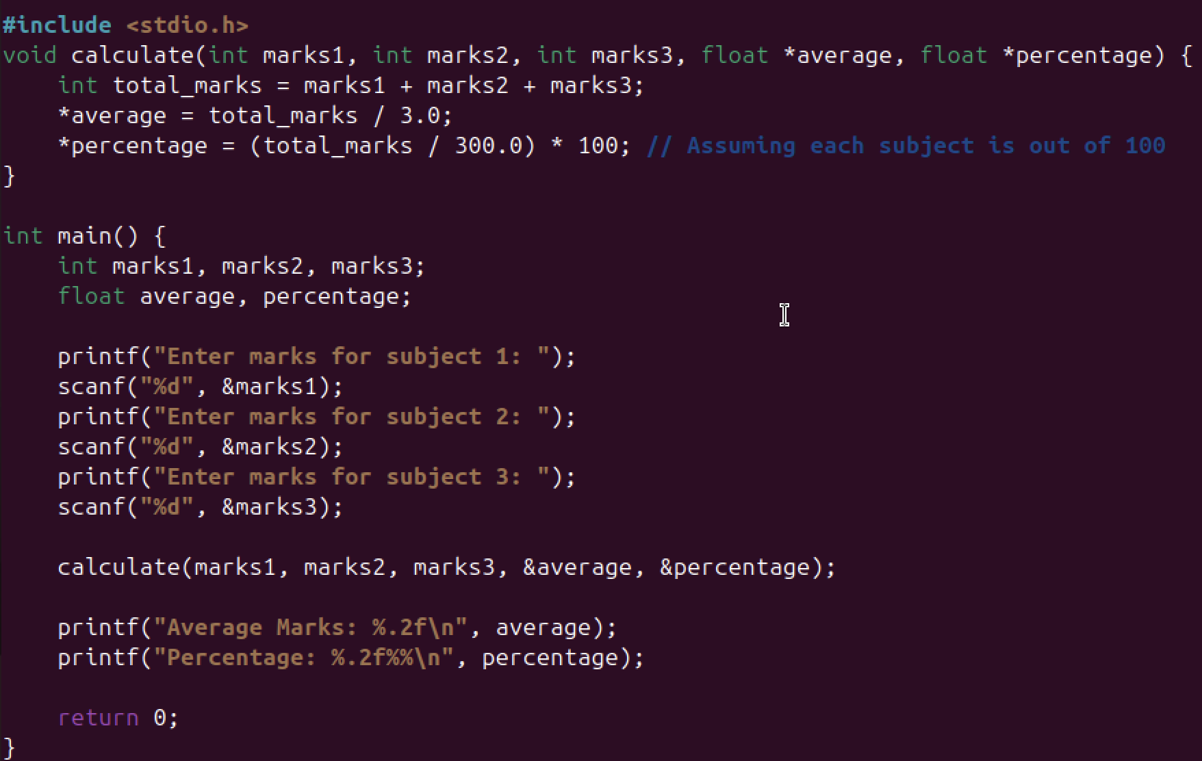

**Output**

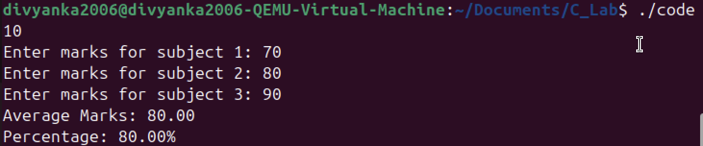

**Explanation**

**Conclusion**

***Thus, the program was successfully executed.***

**Experiment 11**

**Aim**

***WAP to read a list of integers and store it in a single dimensional array. Write a C program to print the second largest integer in a list of integers.***

**Code**

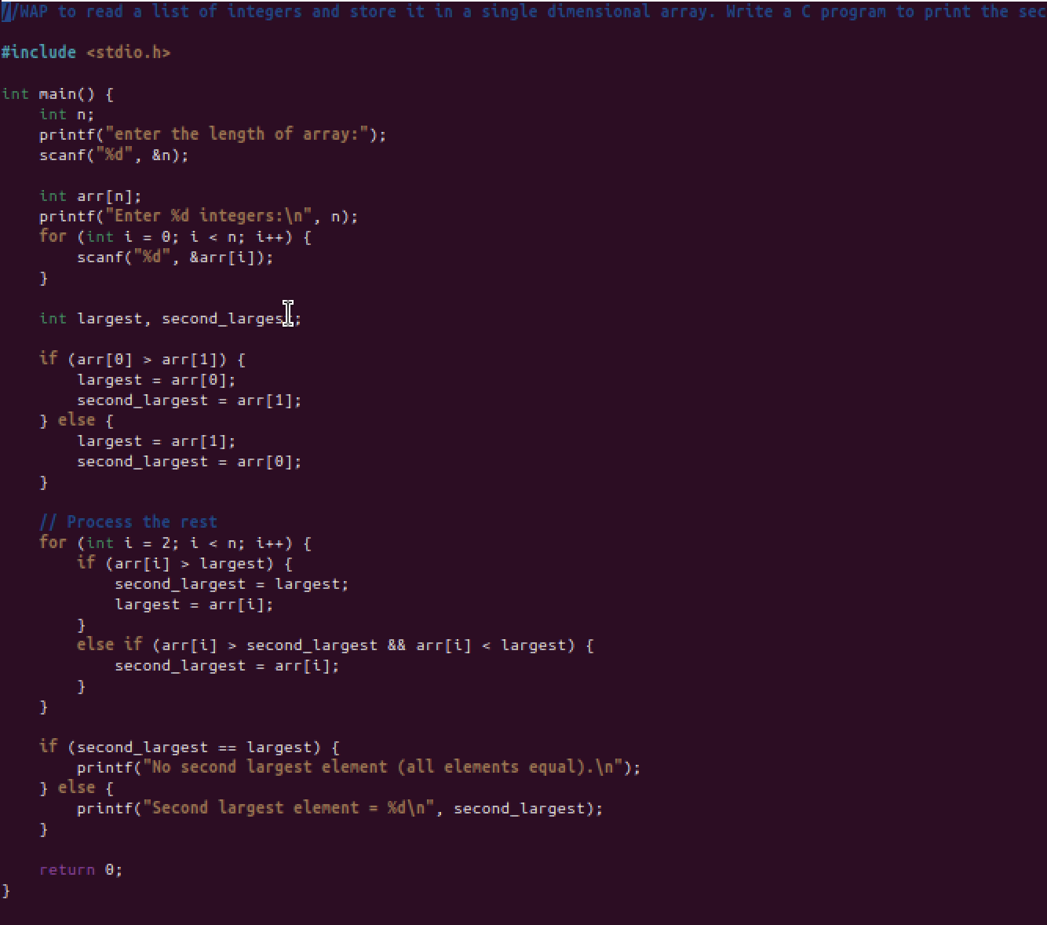

**Output**

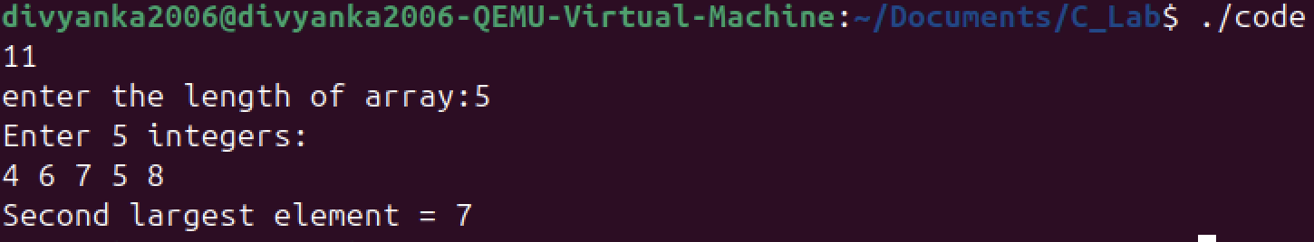

**Explanation**

**Conclusion**

***Thus, the program was successfully executed.***

**Experiment 12**

**Aim**

***WAP to read a list of integers and store it in a single dimensional array. Write a C program to count and display positive, negative, odd, and even numbers in an array.***

**Code**

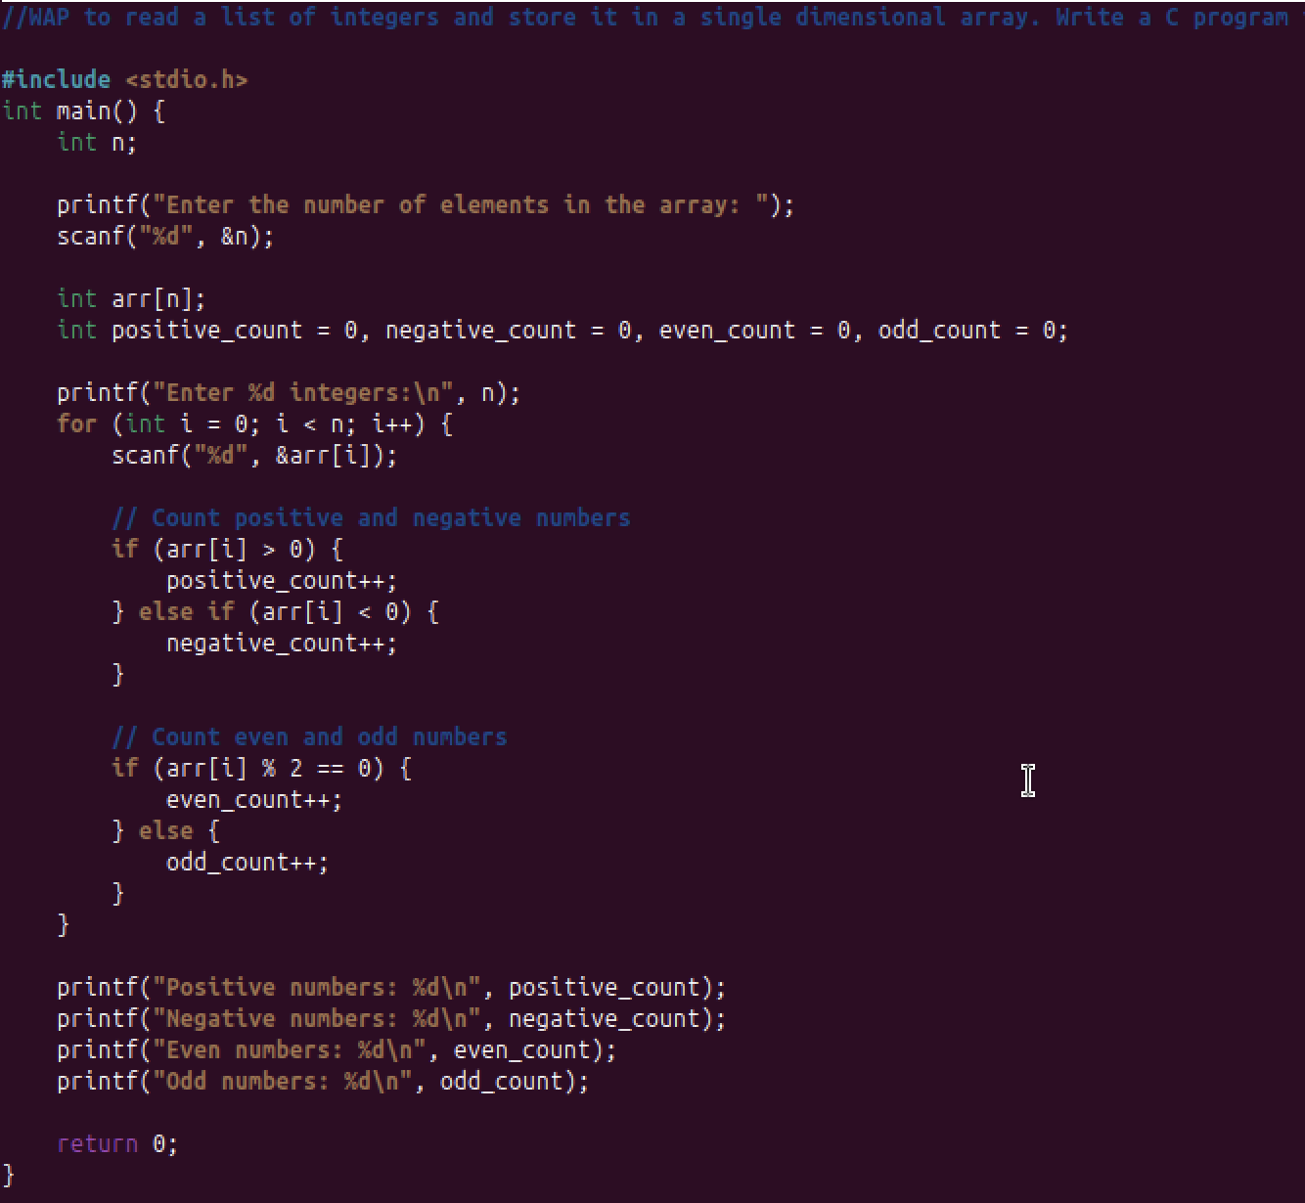

**Output**

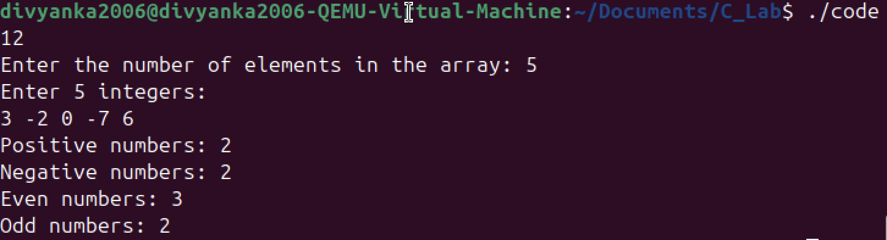

**Explanation**

**Conclusion**

***Thus, the program was successfully executed.***

**Experiment 13**

**Aim**

***Write a function that takes an integer as input and returns its square. Show that the original number in main() remains unchanged.***

**Code**

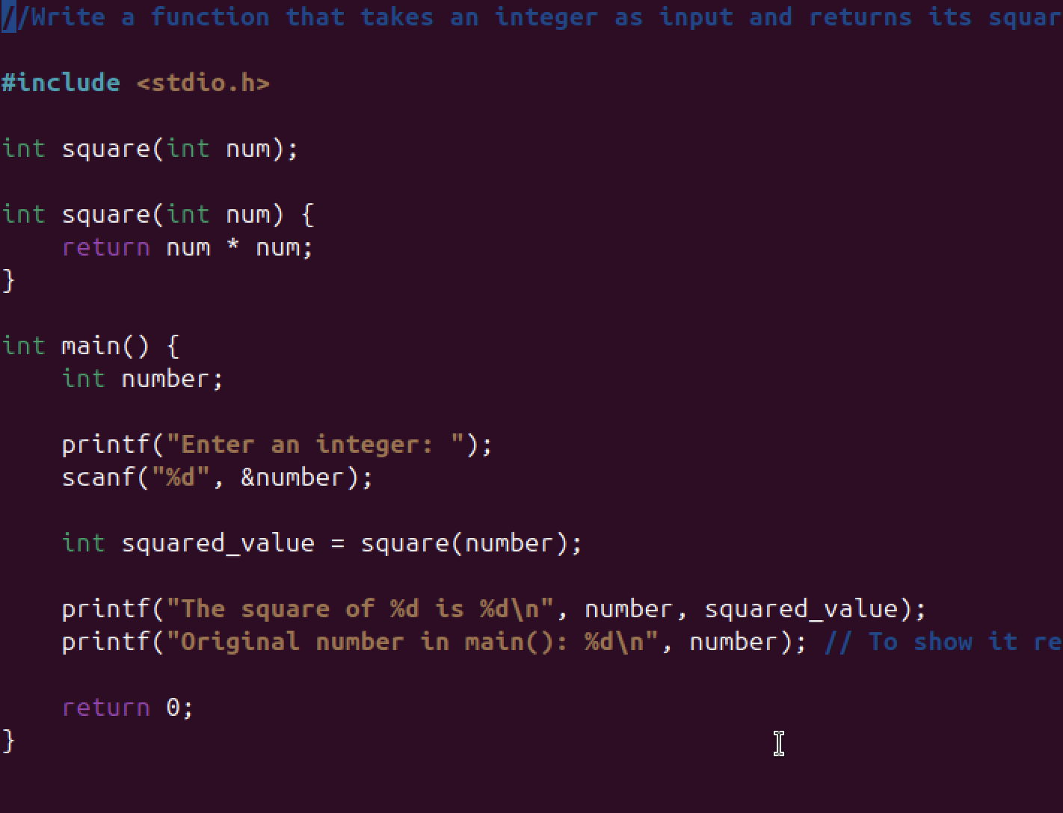

**Output**

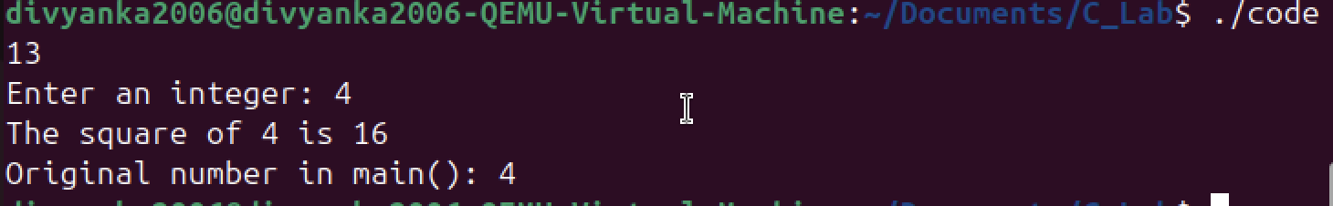

**Explanation**

**Conclusion**

***Thus, the program was successfully executed.***

**Experiment 14**

**Aim**

***Write a function that swaps two integers using call by reference and show that the values are updated in main().***

**Code**

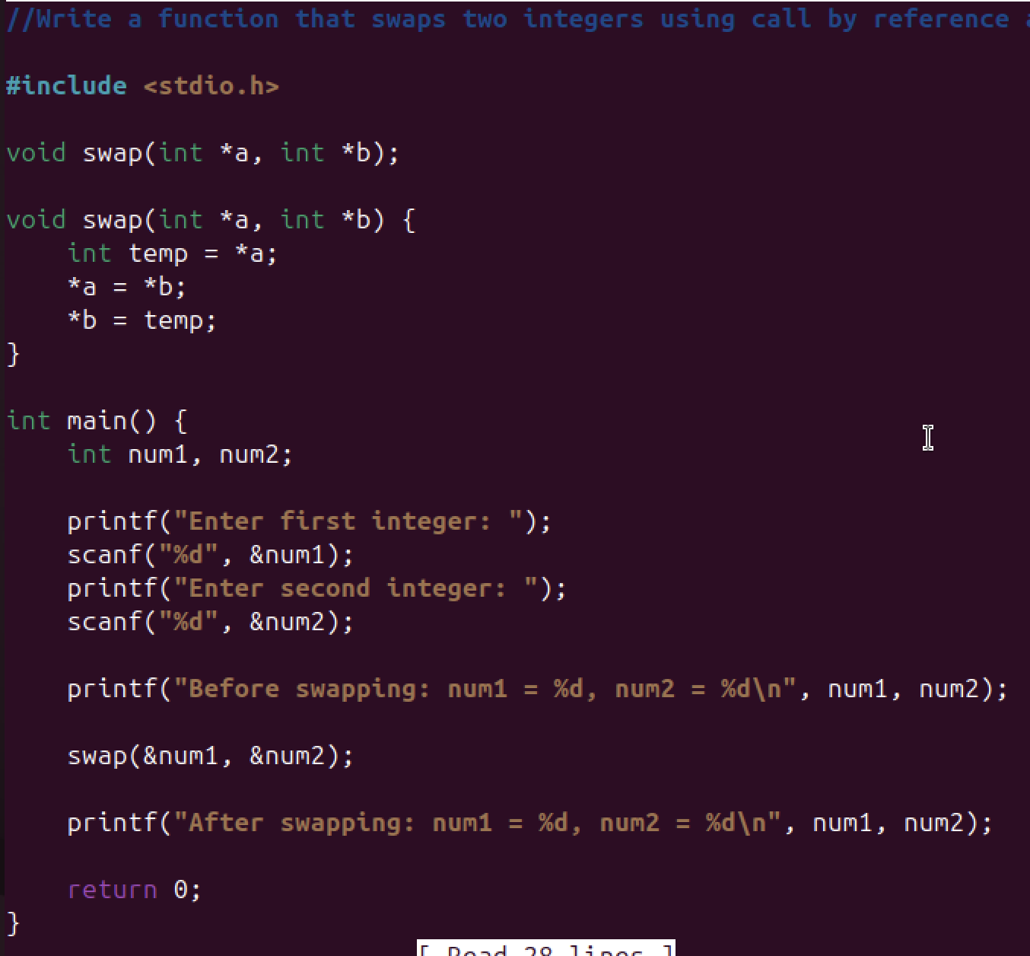

**Output**

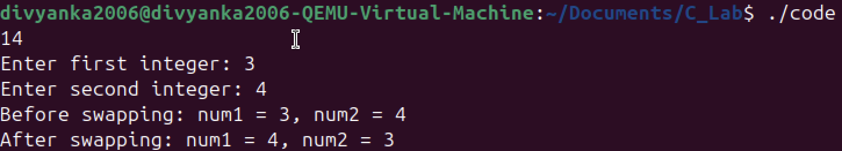

**Explanation**

**Conclusion**

***Thus, the program was successfully executed.***

**Experiment 15**

**Aim**

***Write a function updateSalary(int *salary, int bonus) that increases a salary by a bonus amount. Demonstrate it in main().***

**Code**

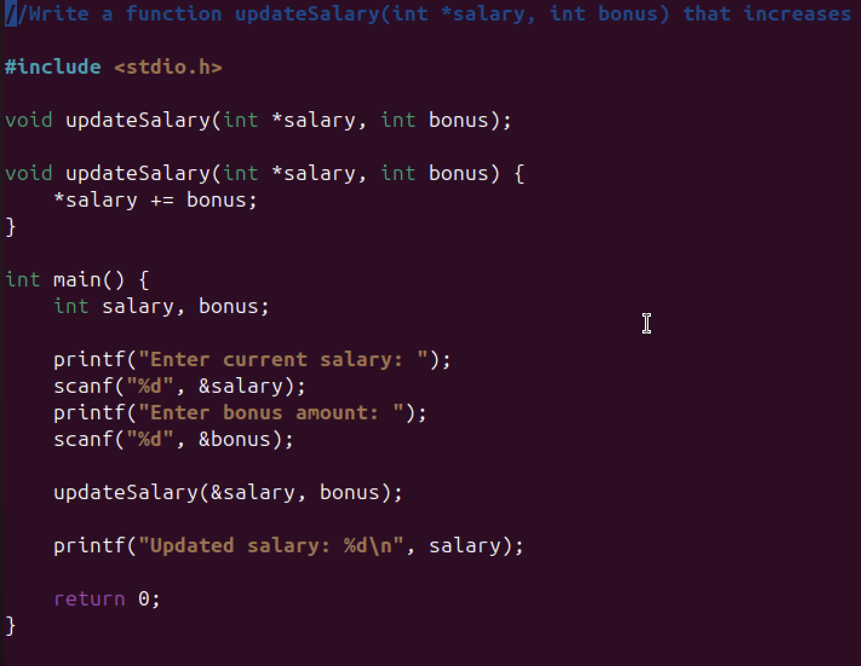

**Output**

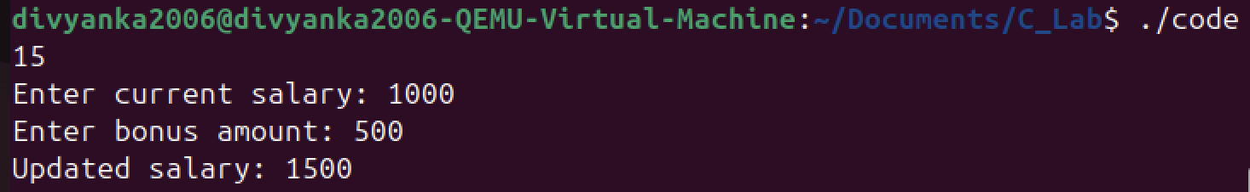

**Explanation**

**Conclusion**

***Thus, the program was successfully executed.***

**Experiment 16**

**Aim**

***Write a function reverseArray(int *arr, int n) that reverses an array using call by reference (array is modified in main()).***

**Code**

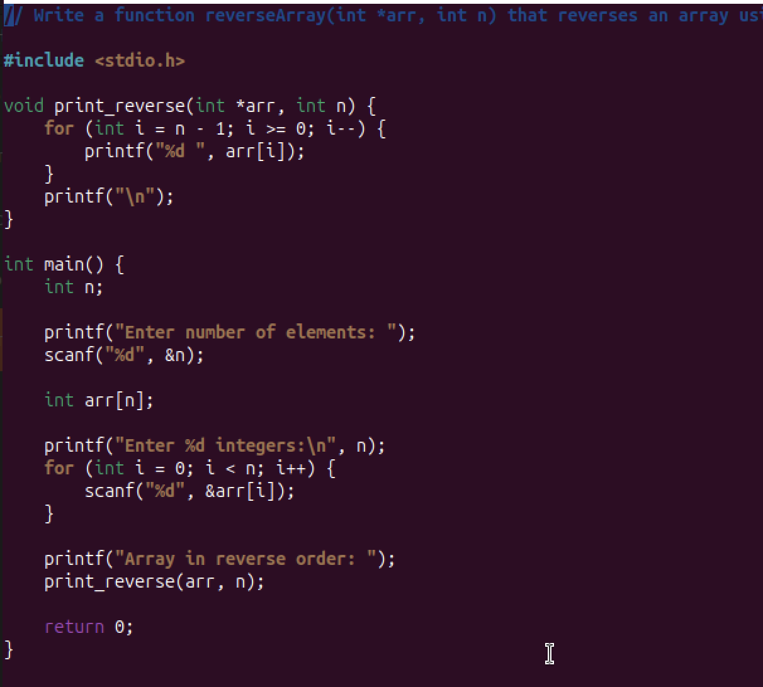

**Output**

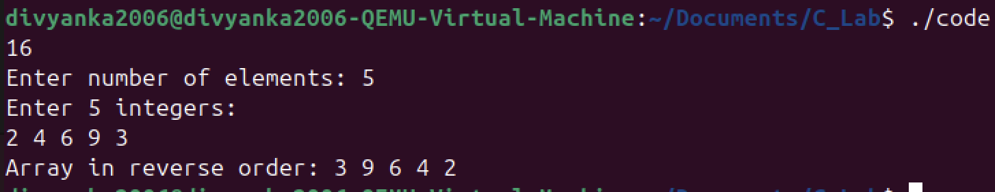

**Explanation**

**Conclusion**

***Thus, the program was successfully executed.***

**Experiment 17**

**Aim**

***Define a macro PASS_MARKS as 40. Write a program that takes a student’s marks and prints whether they passed or failed using the macro.***

**Code**

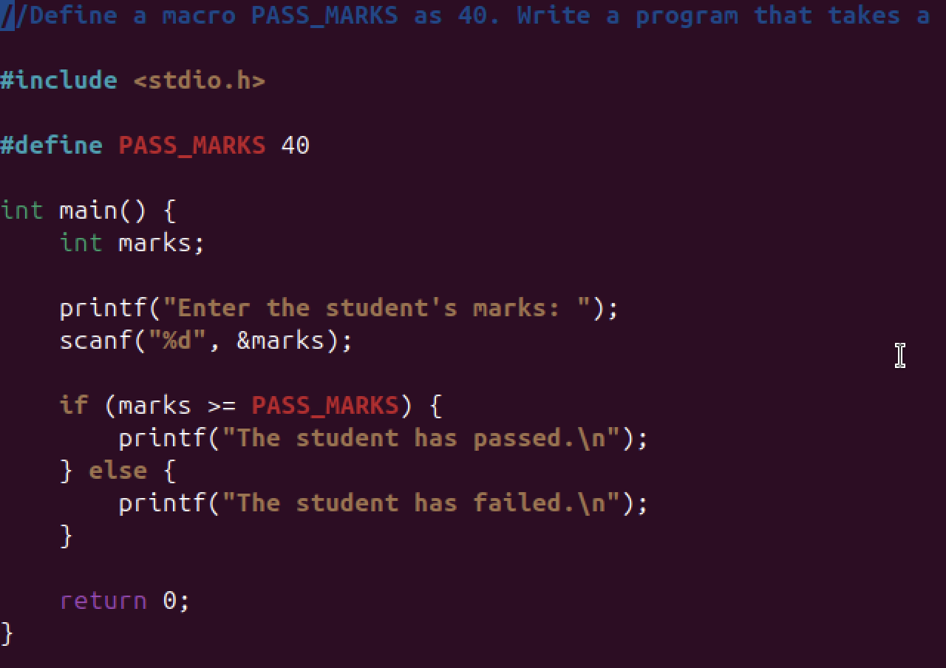

**Output**

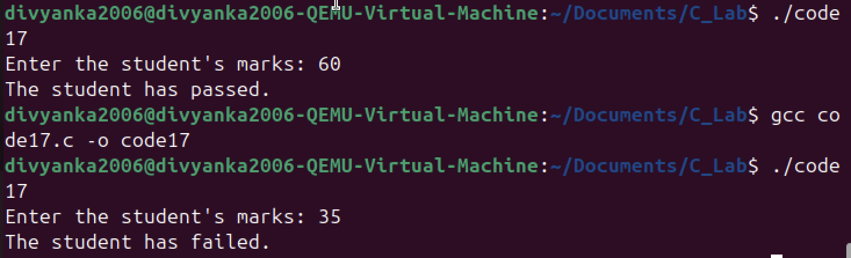

**Explanation**

**Conclusion**

***Thus, the program was successfully executed.***

**Experiment 18**

**Aim**

***Define a macro to convert kilometers to meters. Write a program that takes input in kilometers and prints the result in meters.***

**Code**

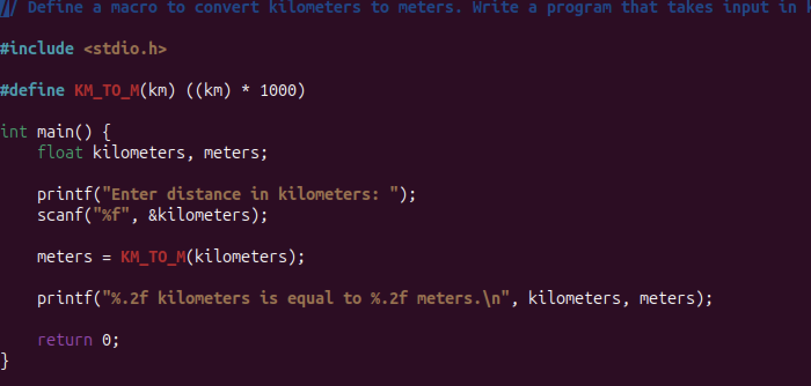

**Output**

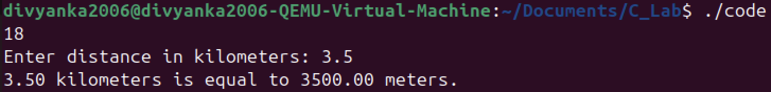

**Explanation**

**Conclusion**

***Thus, the program was successfully executed.***

**Experiment 19**

**Aim**

***Declare a global variable outside all functions and use it inside various functions to understand its accessibility.***

**Code**

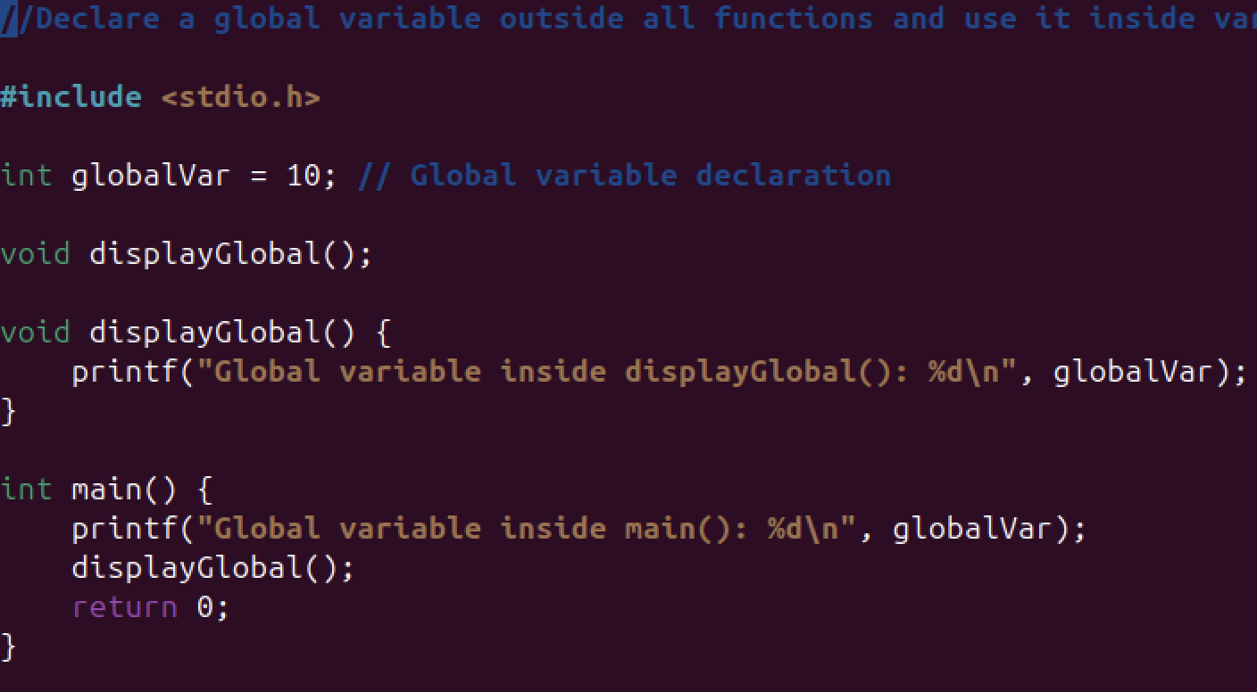

**Output**

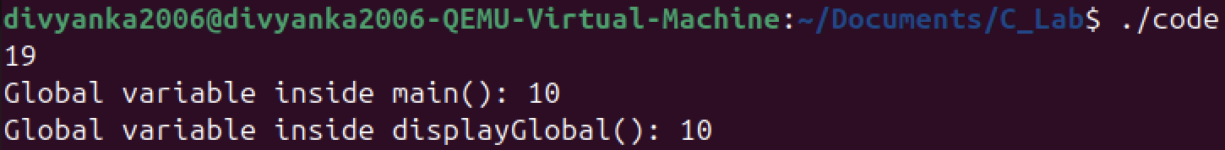

**Explanation**

**Conclusion**

***Thus, the program was successfully executed.***

**Experiment 20**

**Aim**

***Declare a local variable inside a function and try to access it outside the function. Compare this with accessing the global variable from within the function.***

**Code**

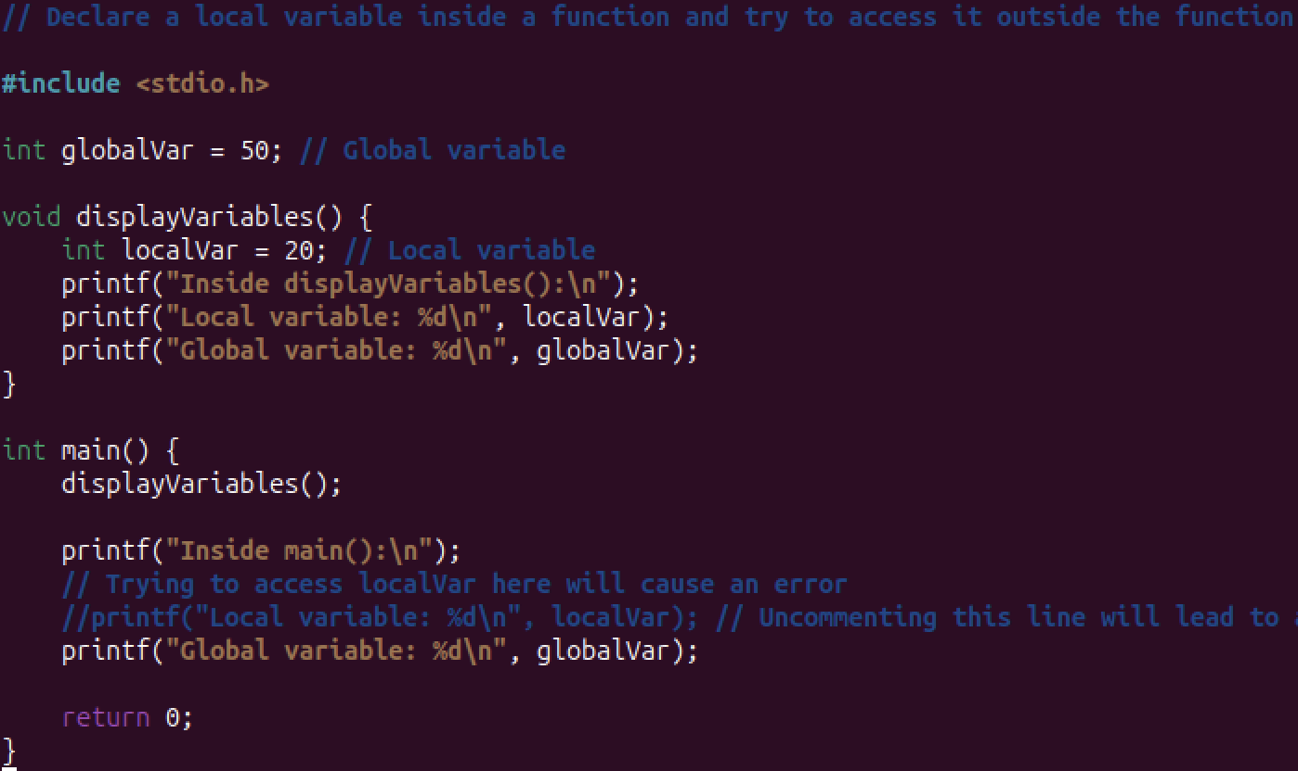

**Output**

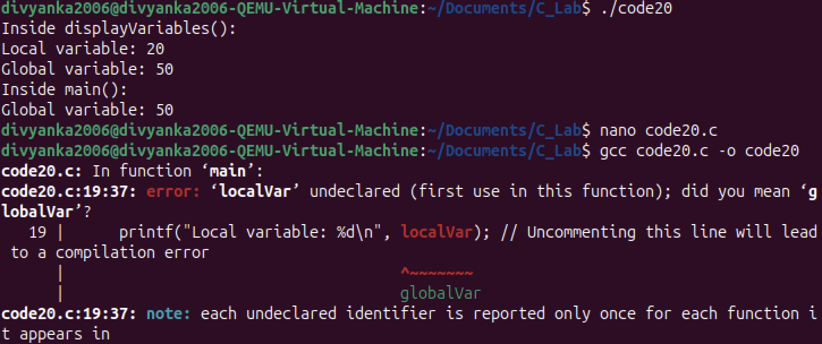

**Explanation**

**Conclusion**

***Thus, the program was successfully executed.***

**Experiment 21**

**Aim**

***Declare variables within different code blocks (enclosed by curly braces) and test their accessibility within and outside those blocks.***

**Code**

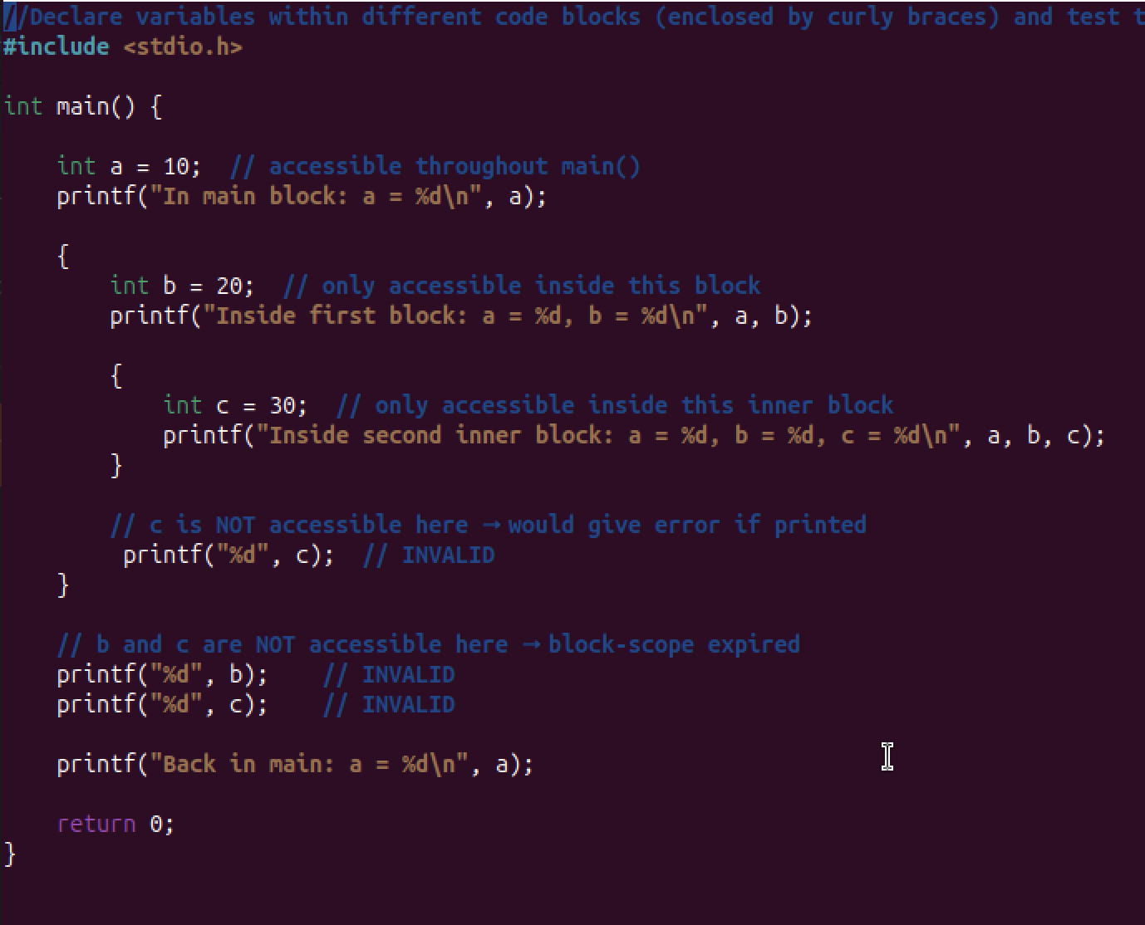

**Output**

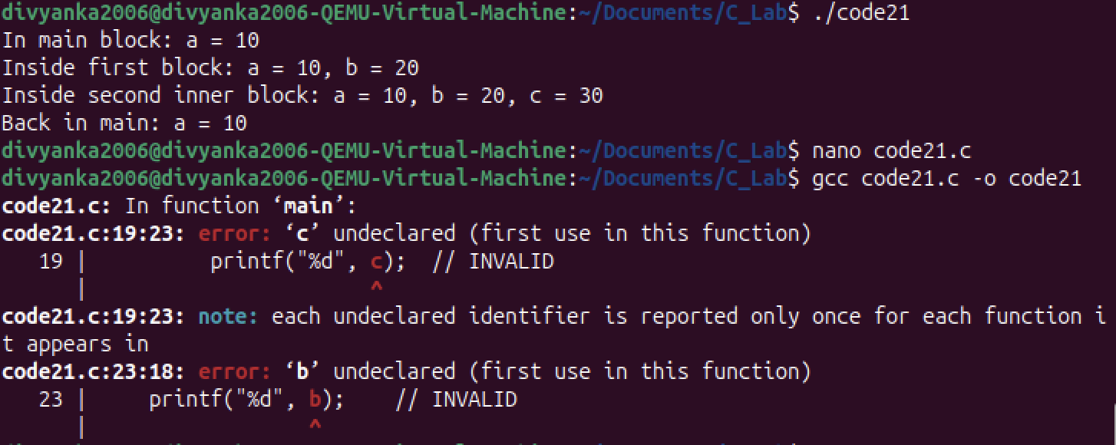

**Explanation**

**Conclusion**

***Thus, the program was successfully executed.***

**Experiment 22**

**Aim**

***Declare a static local variable inside a function. Observe how its value persists across function calls.***

**Code**

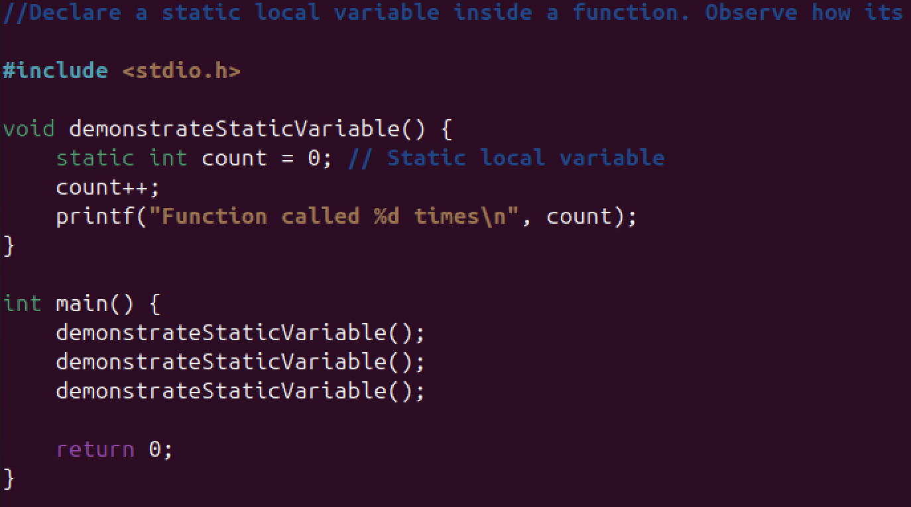

**Output**

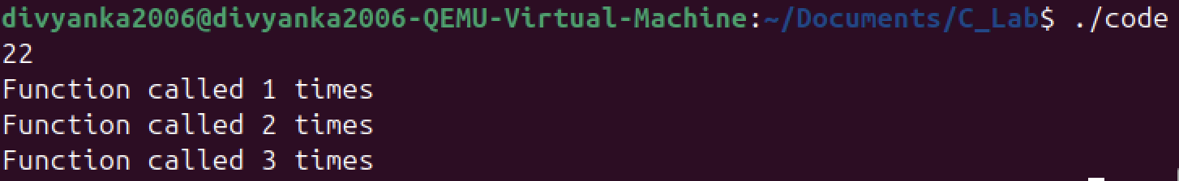

**Explanation**

**Conclusion**

***Thus, the program was successfully executed.***

**Experiment 23**

**Aim**

***Develop a recursive and non-recursive function FACT(num) to find the factorial of a number, n!, defined by FACT(n) = 1, if n = 0. Otherwise, FACT(n) = n * FACT(n-1). Using this function, write a C program to compute the binomial coefficient. Tabulate the results for different values of n and r with suitable messages.***

**Code**

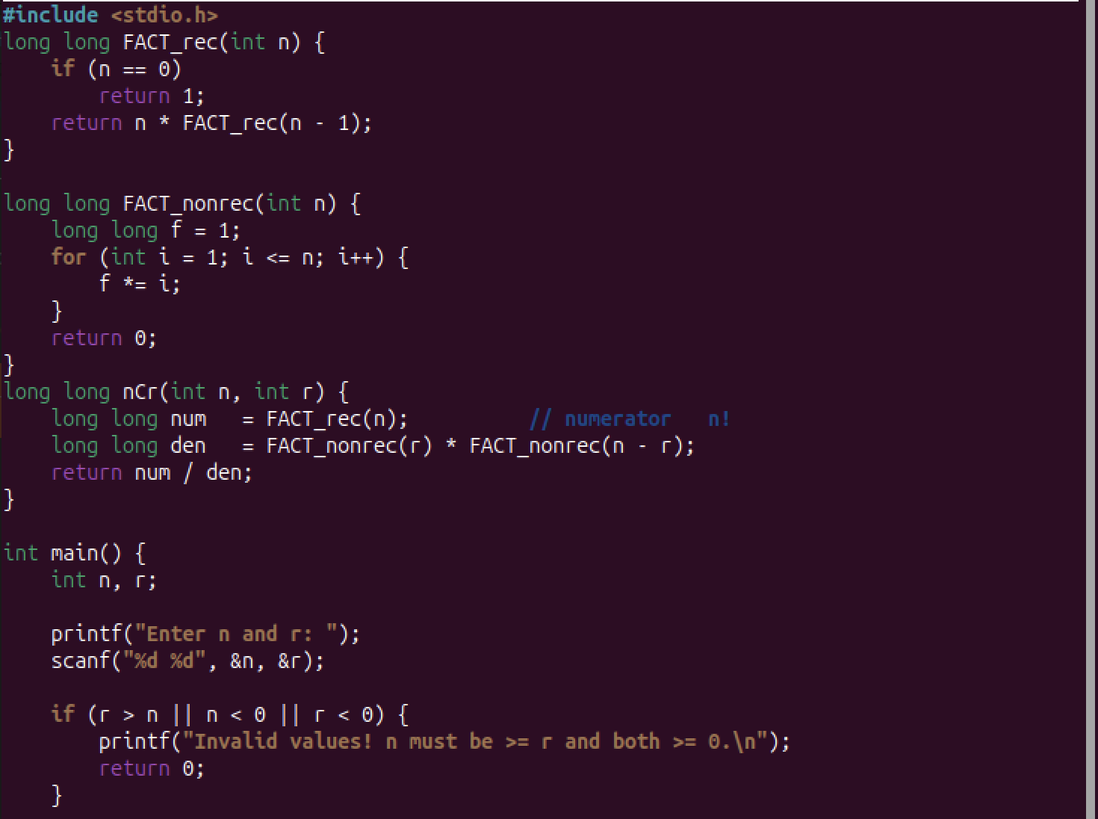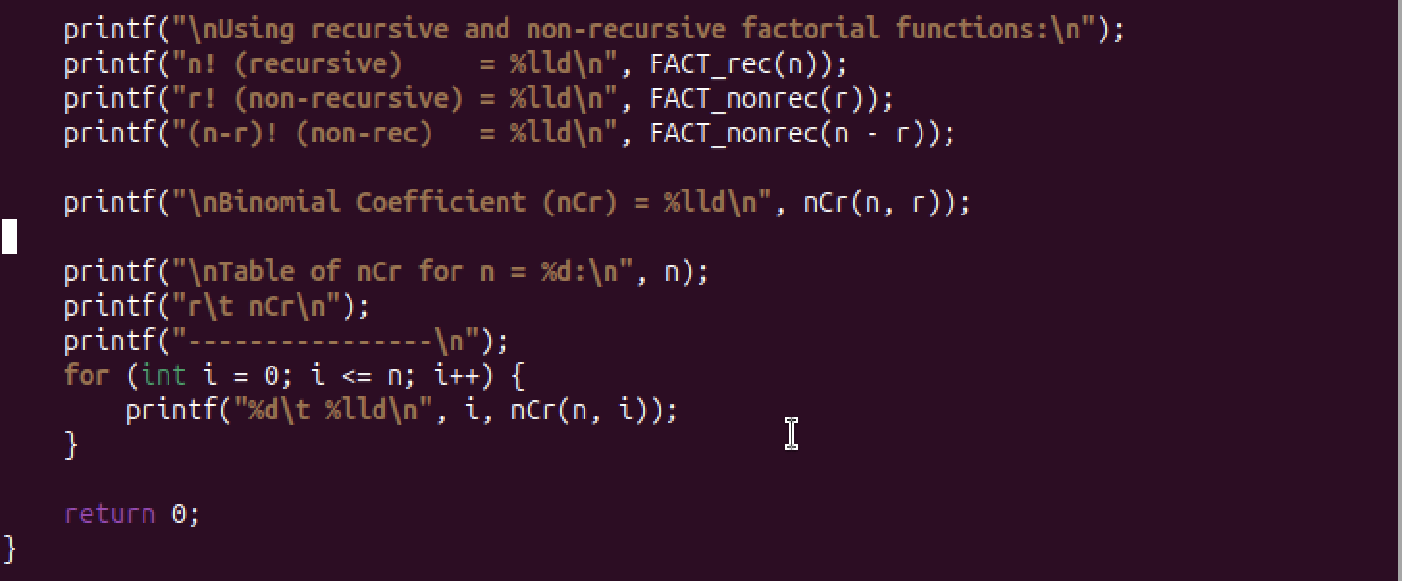

**Output**

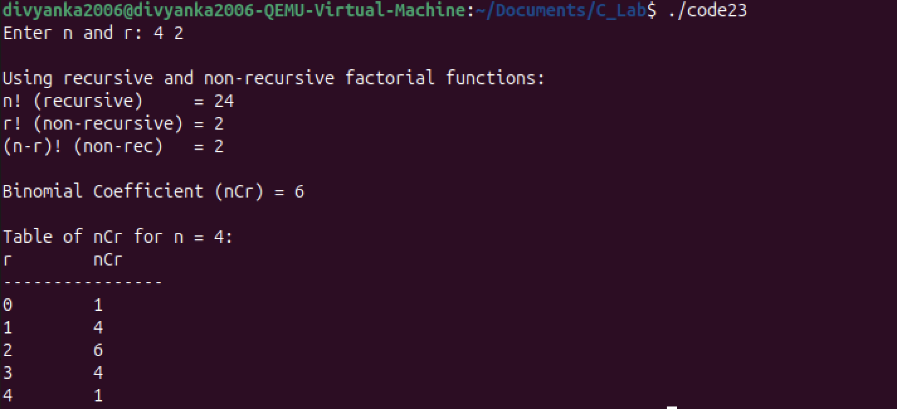

**Explanation**

**Conclusion**

***Thus, the program was successfully executed.***

**Experiment 24**

**Aim**

***WAP to find the largest and smallest number using conditional statements and functions.***

**Code**

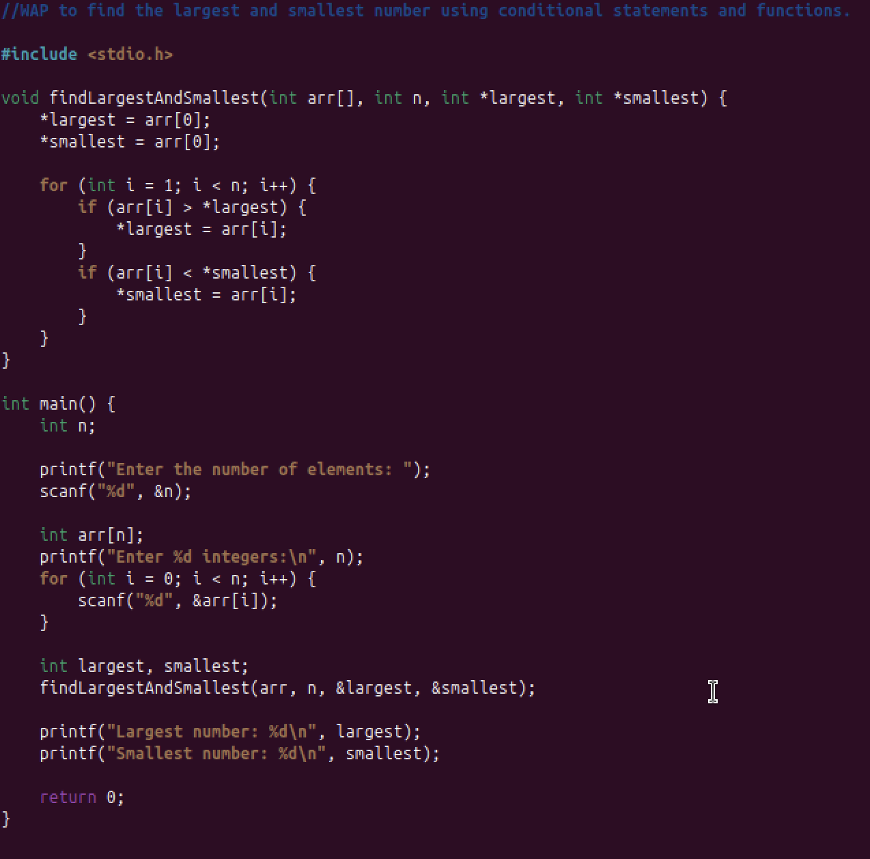

**Output**

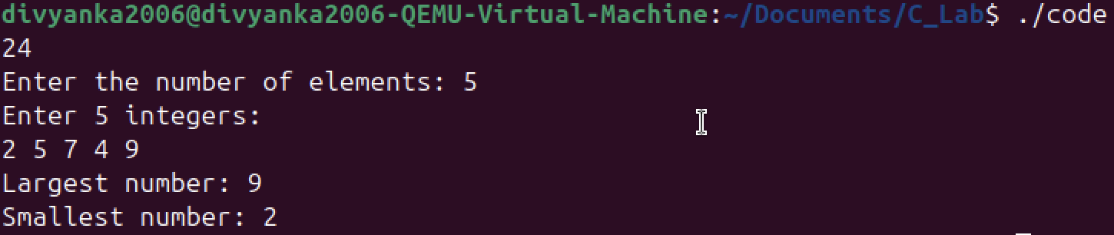

**Explanation**

**Conclusion**

***Thus, the program was successfully executed.***

**Experiment 25**

**Aim**

***WAP to find the largest and smallest number using macros.***

**Code**

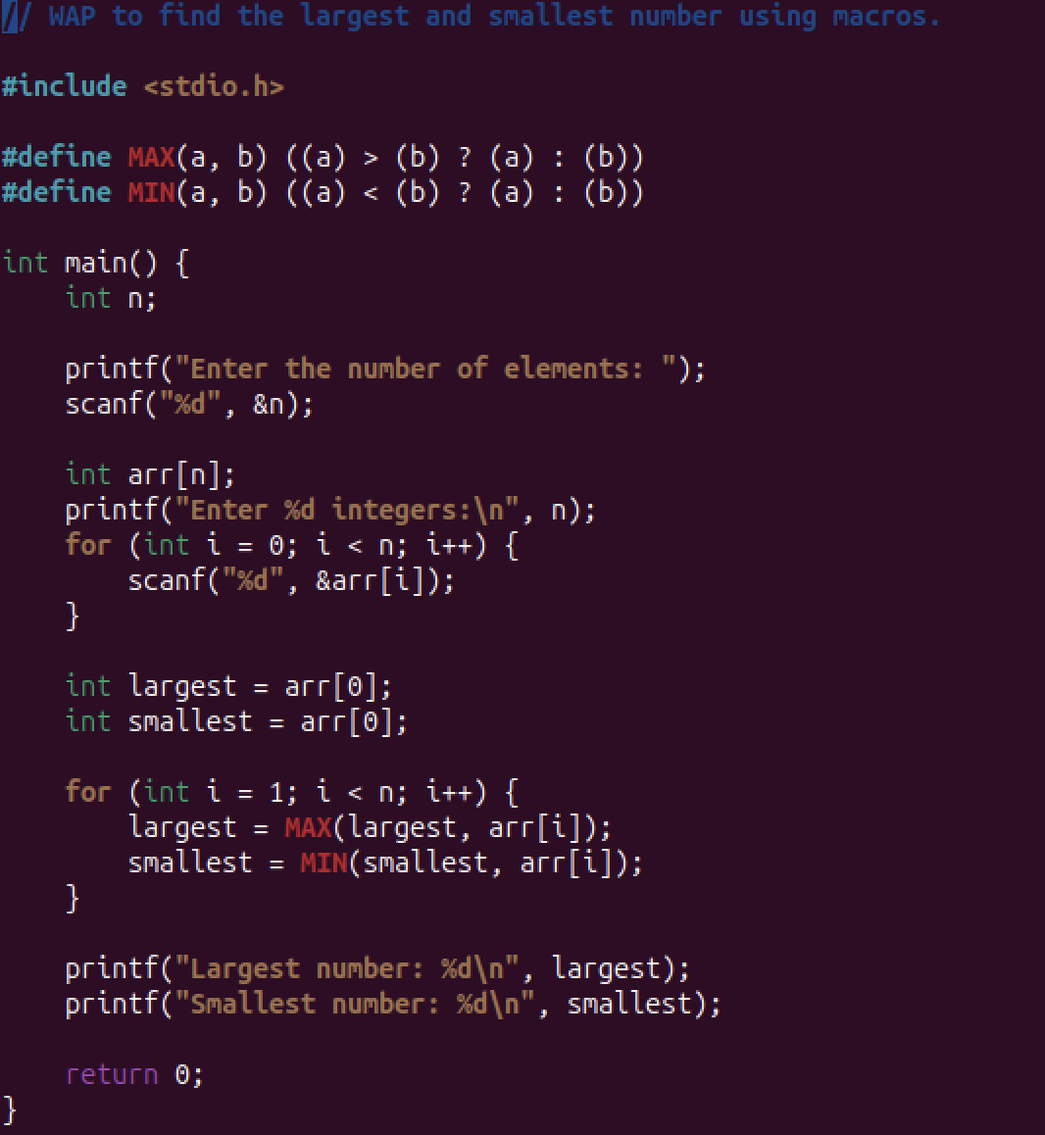

**Output**

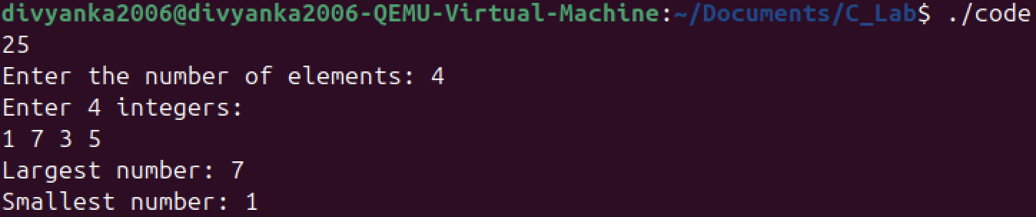

**Explanation**

**Conclusion**

***Thus, the program was successfully executed.***

**Experiment 26**

**Aim**

***Write a simple calculator, and do not stop till uses says yes.***

**Code**

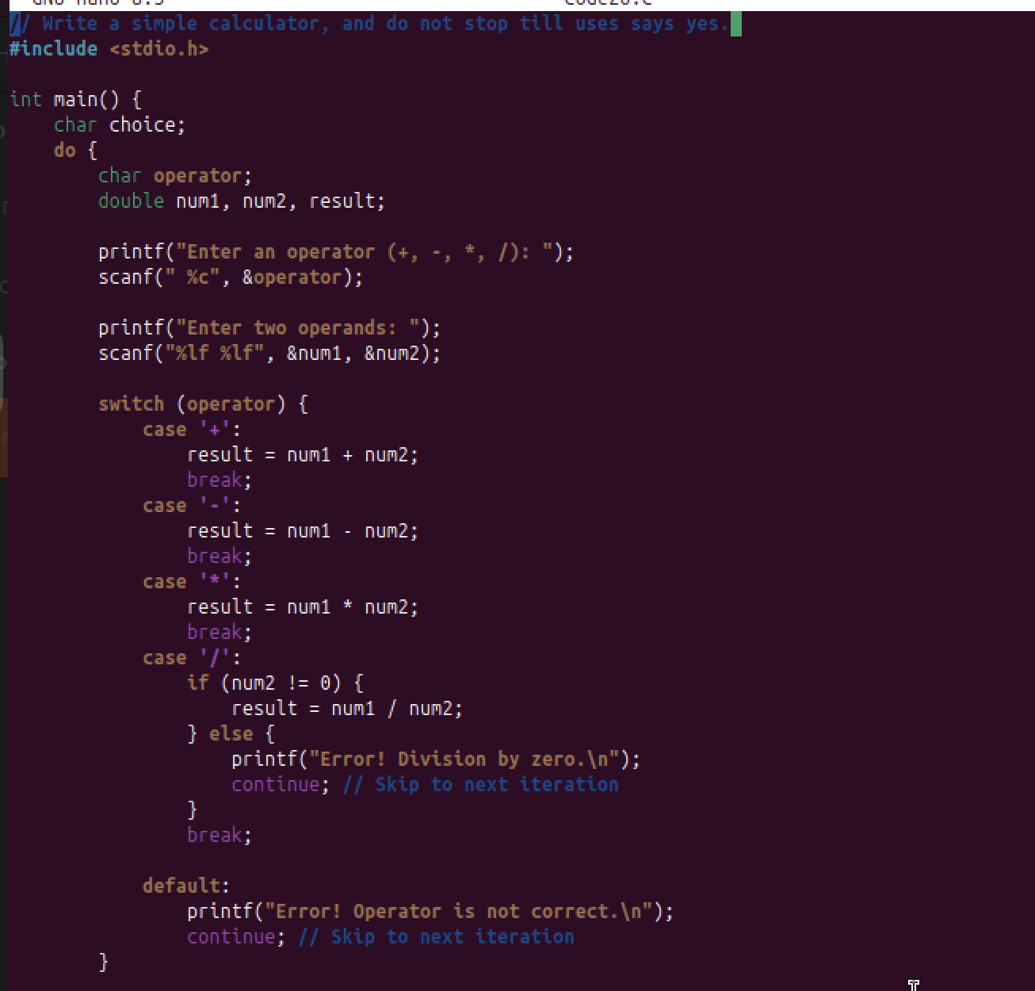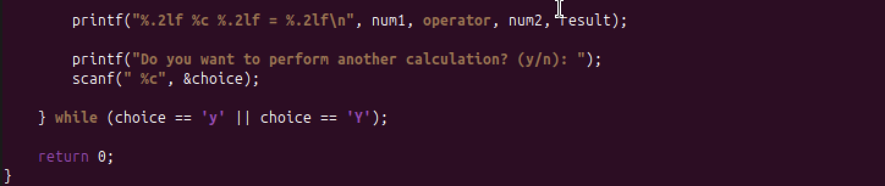

**Output**

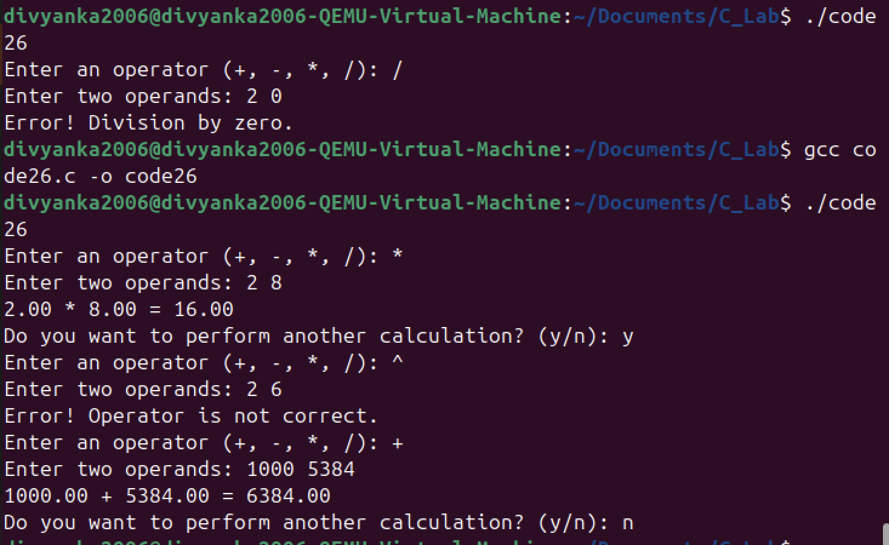

**Explanation**

**Conclusion**

***Thus, the program was successfully executed.***

**Experiment 27**

**Aim**

***WAP to read n integers (where n ≤ 10) into an array and display the array elements in reverse order using a function.***

**Code**

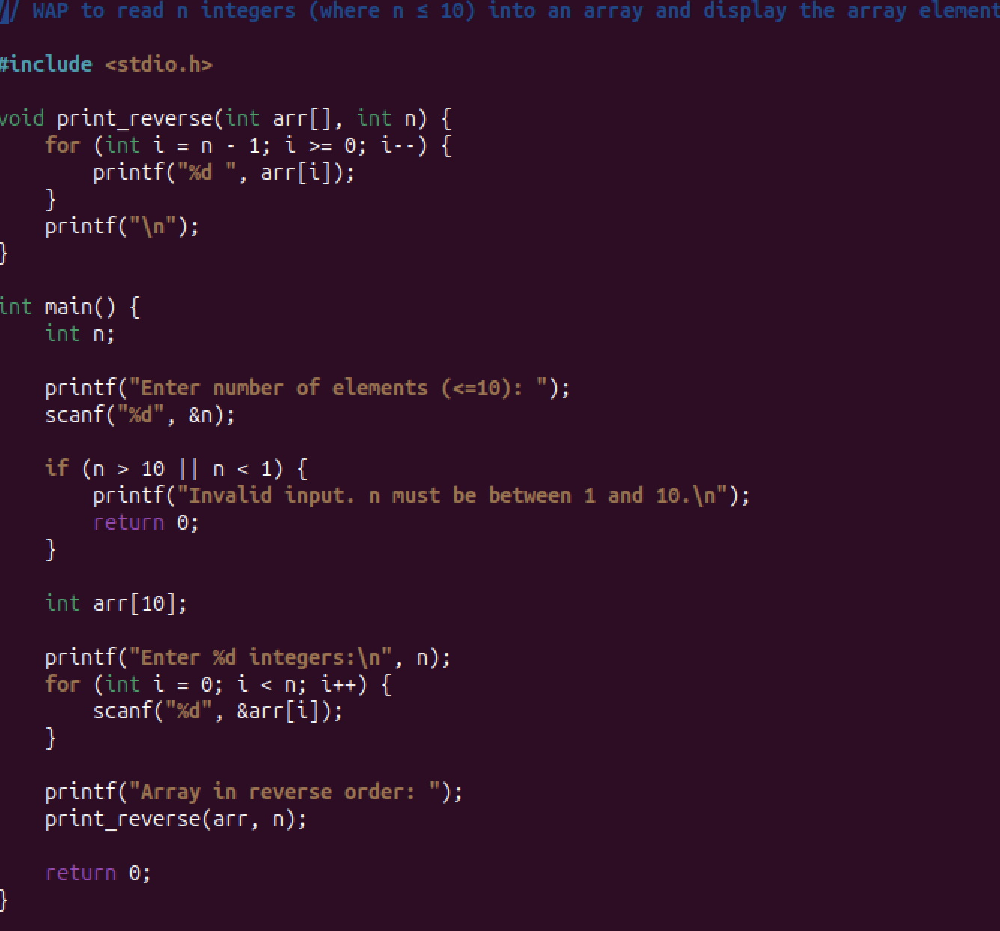

**Output**

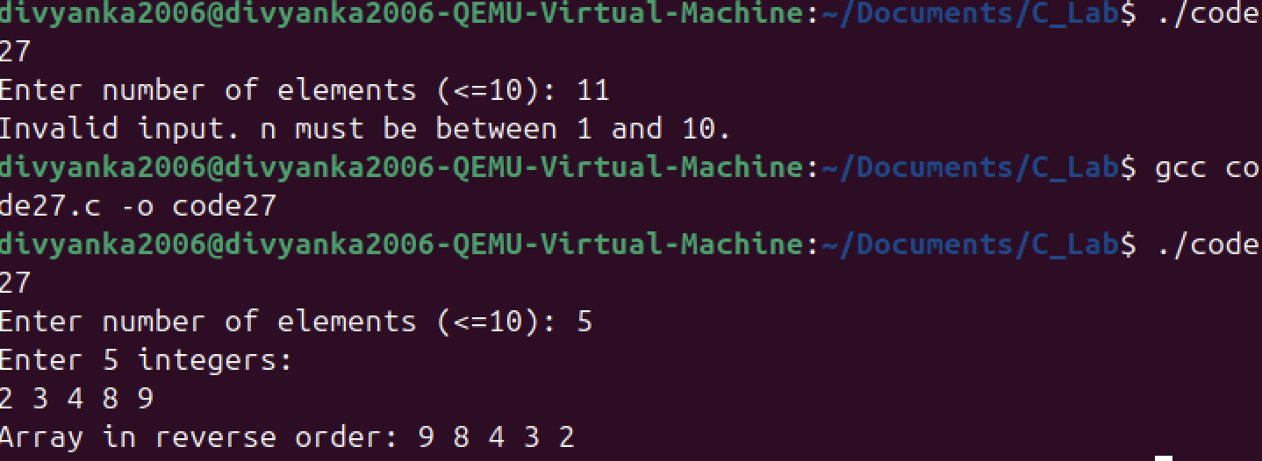

**Explanation**

**Conclusion**

***Thus, the program was successfully executed.***

**Experiment 28**

**Aim**

***Write a C program that uses functions to perform the following operations:***

***a. Reading a complex number.***

***b. Writing a complex number.***

***c. Addition and subtraction of two complex numbers***

**Code**

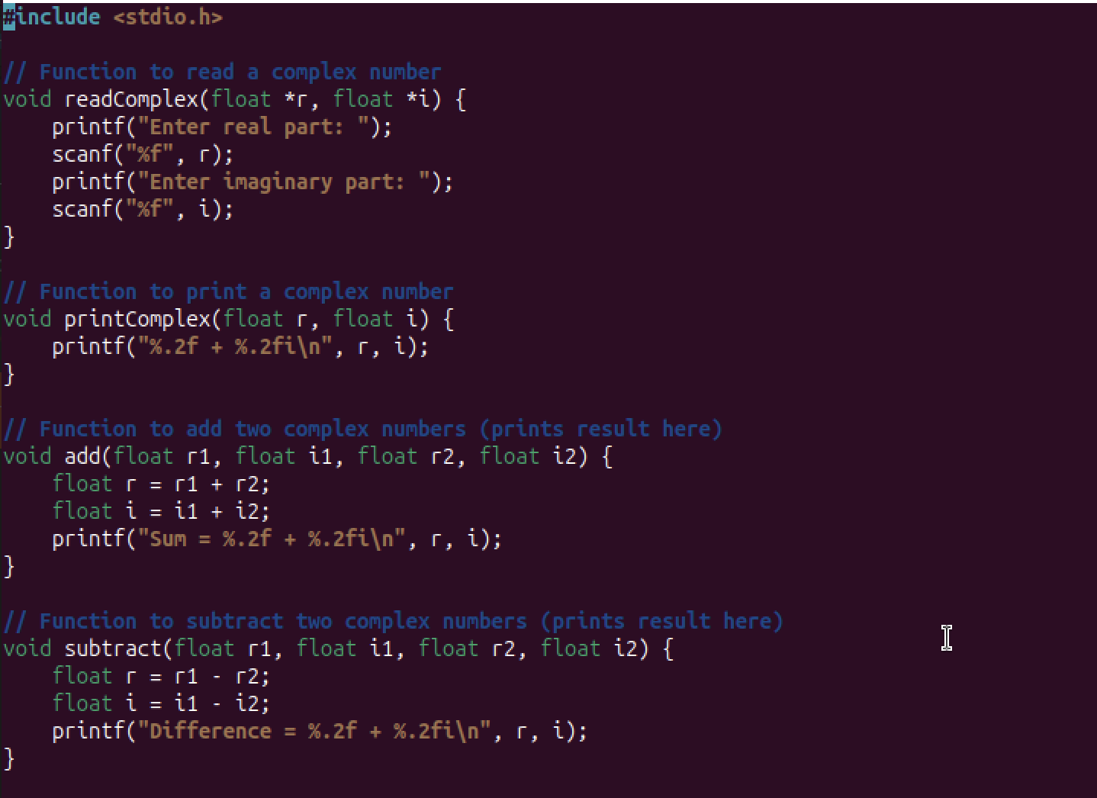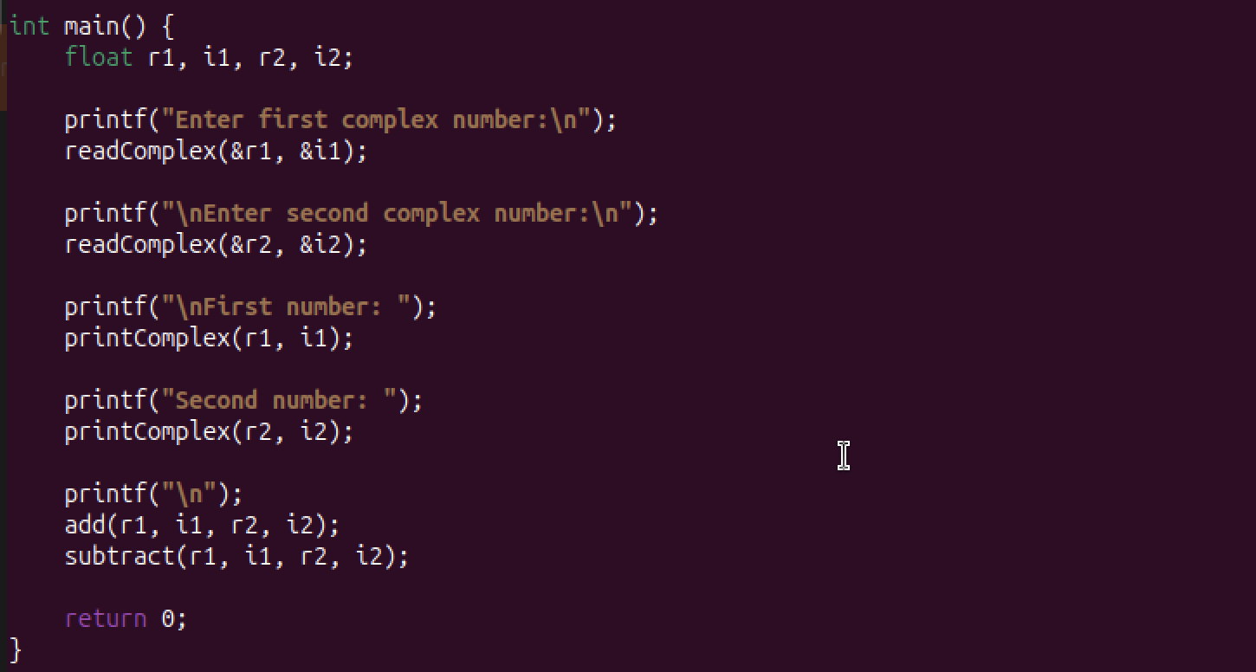

**Output**

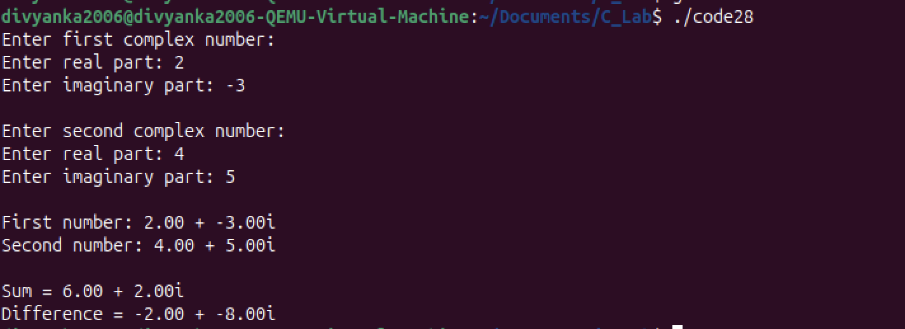

**Explanation**

**Conclusion**

***Thus, the program was successfully executed.***

**Experiment 29**

**Aim**

***Develop a recursive function GCD (num1, num2) that accepts two integer arguments. Write a C program that invokes this function to find the greatest common divisor of two given integers.***

**Code**

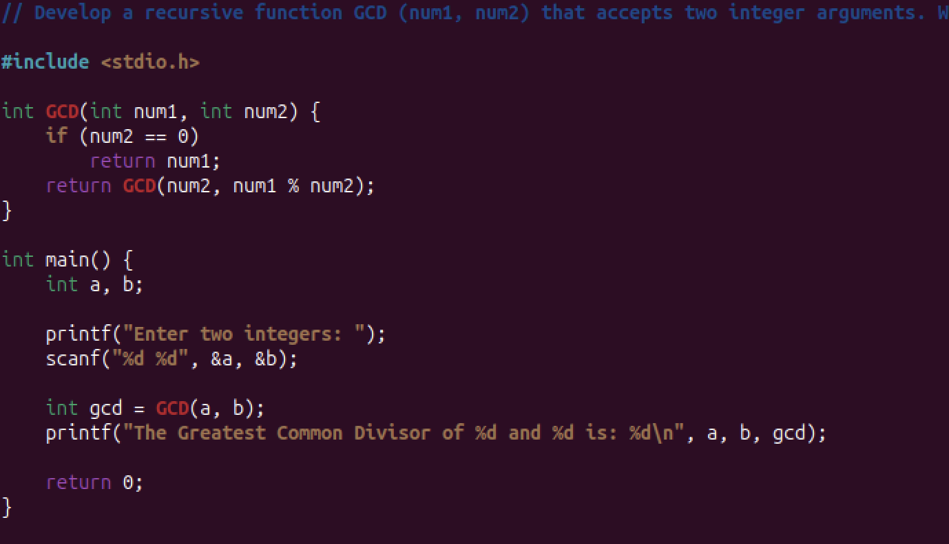

**Output**



**Explanation**

**Conclusion**

***Thus, the program was successfully executed.***

**Experiment 30**

**Aim**

***Develop a recursive function FIBO (num) that accepts an integer argument. Write a C program that invokes this function to generate the Fibonacci sequence up to num.***

**Code**

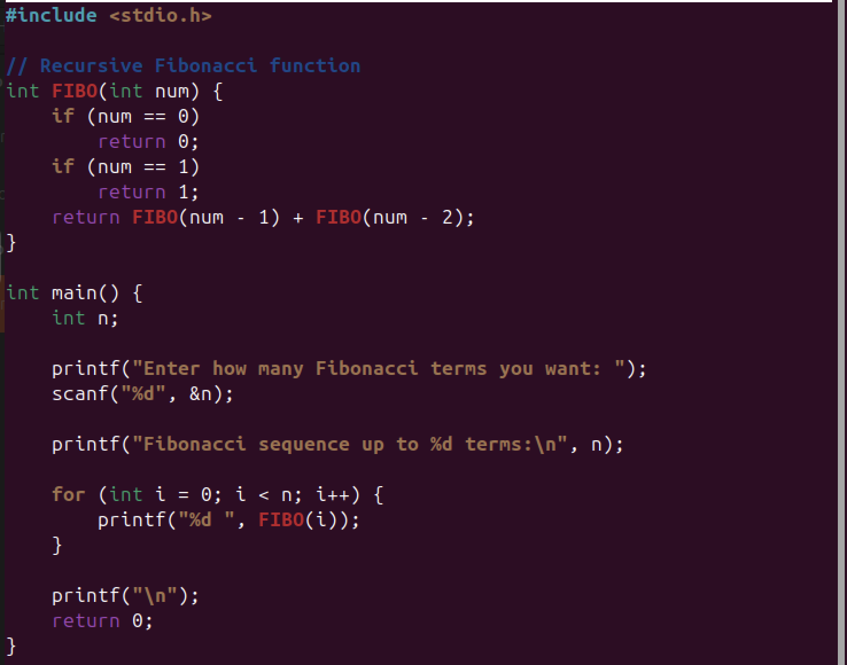

**Output**

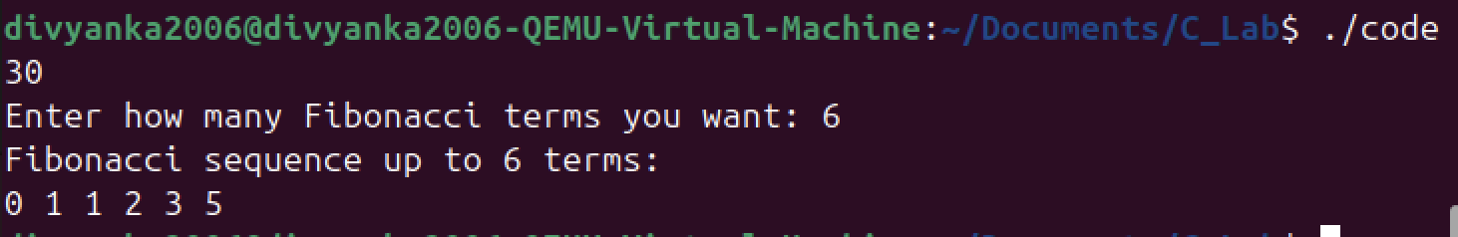

**Explanation**

**Conclusion**

***Thus, the program was successfully executed.***

**Experiment 31**

**Aim**

***Develop a C function ISPRIME (num) that accepts an integer argument and returns 1 if the argument is prime, a 0 otherwise. Write a C program that invokes this function to generate prime numbers between the given ranges.***

**Code**

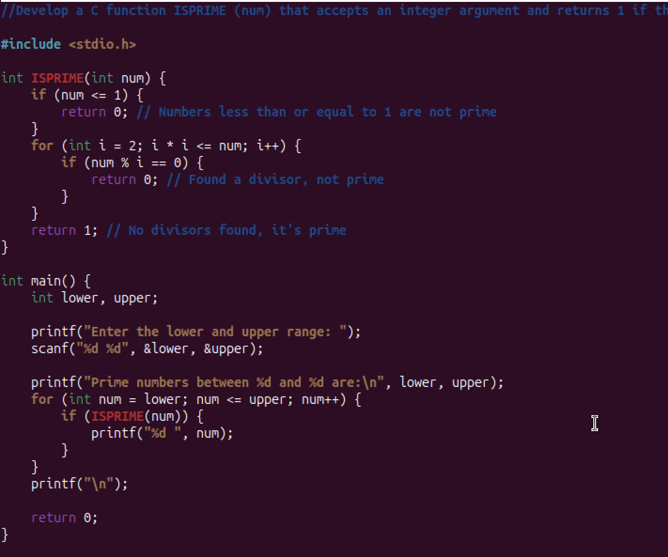

**Output**

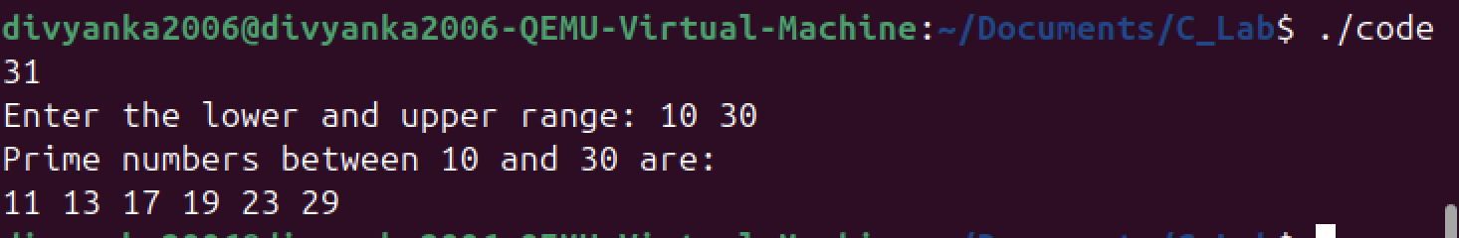

**Explanation**

**Conclusion**

***Thus, the program was successfully executed.***

**Experiment 32**

**Aim**

***Develop a function REVERSE (str) that accepts a string argument. Write a C program that invokes this function to find the reverse of a given string.***

**Code**

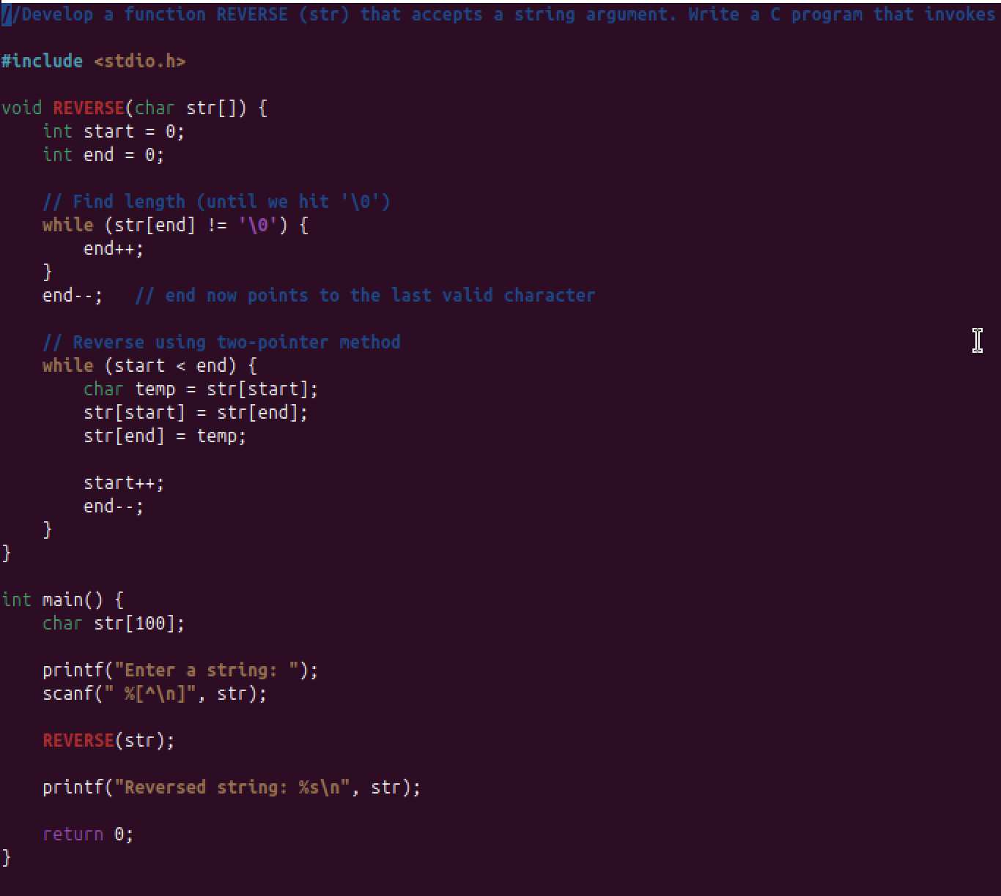

**Output**

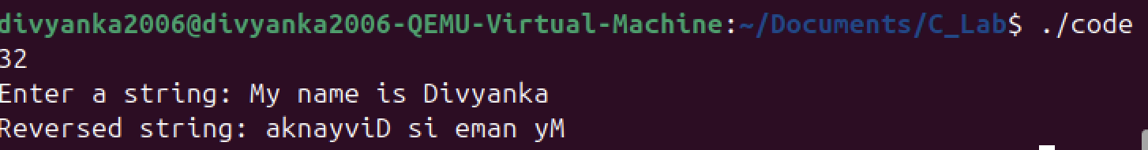

**Explanation**

**Conclusion**

***Thus, the program was successfully executed.***

**Experiment 33**

**Aim**

***Write a program to apply bitwise OR, AND and NOT operators on bit level.***

**Code**

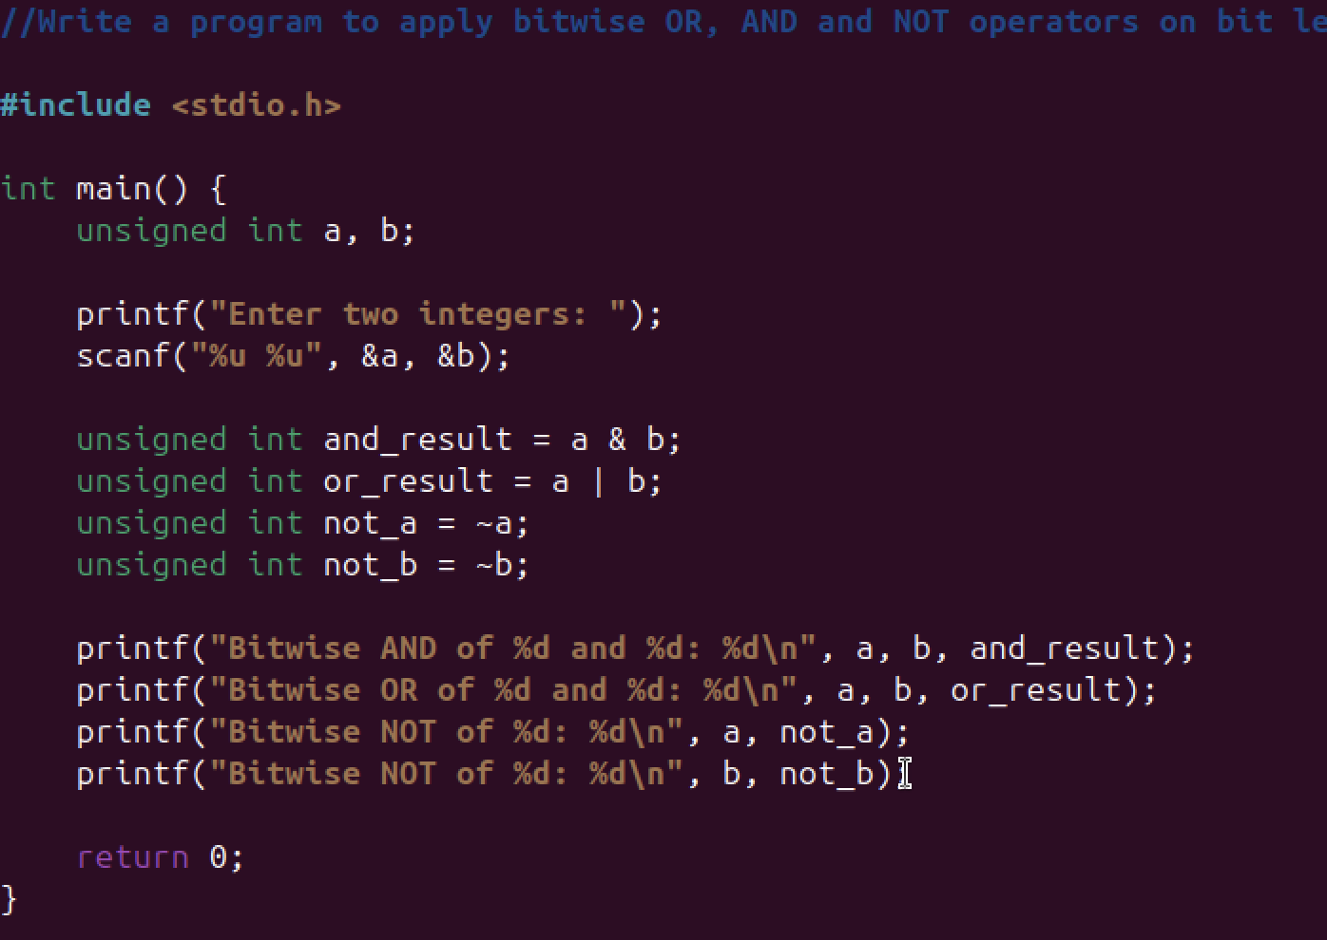

**Output**

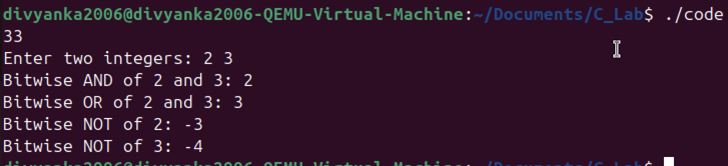

**Explanation**

**Conclusion**

***Thus, the program was successfully executed.***

**Experiment 34**

**Aim**

***Write a program to apply left shift and right shift operator.***

**Code**

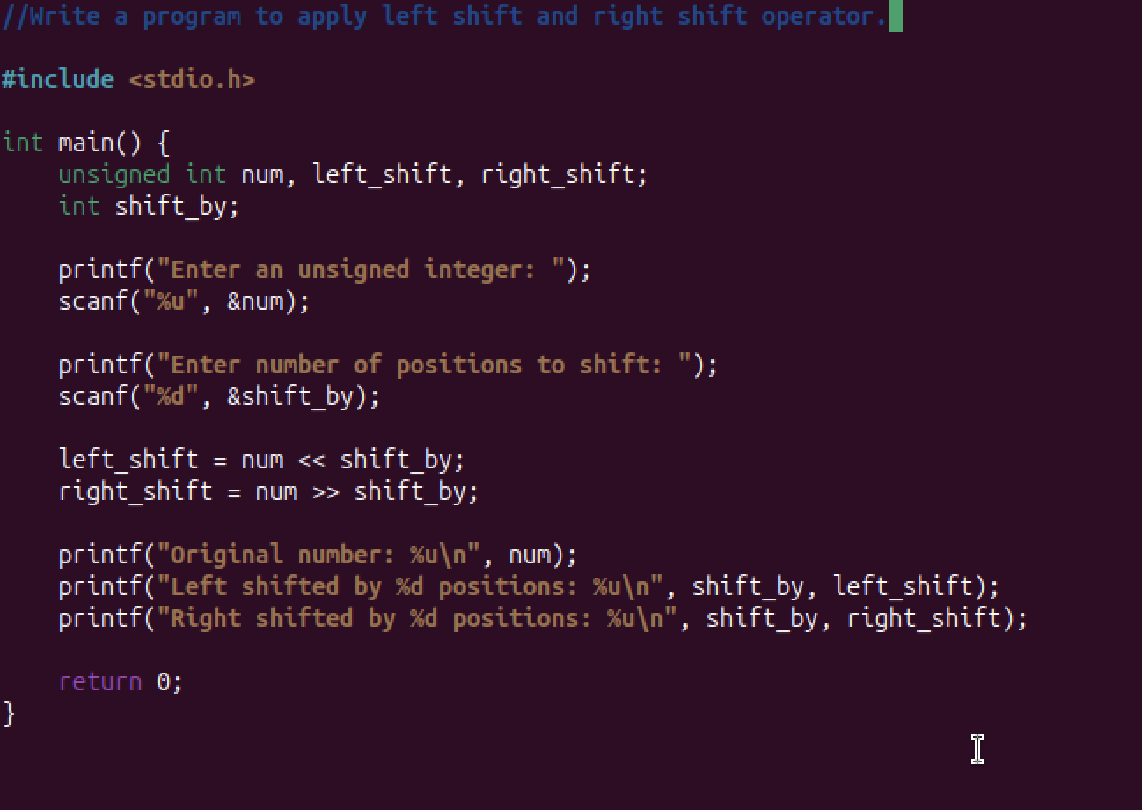

**Output**

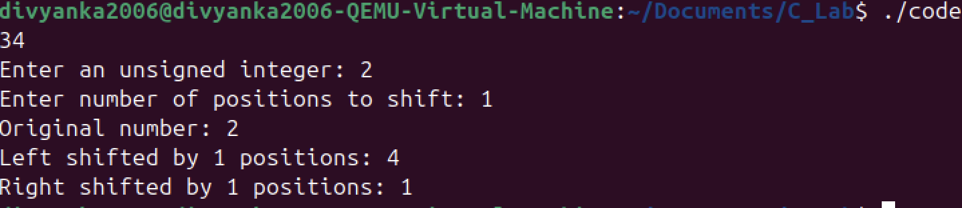

**Explanation**

**Conclusion**

***Thus, the program was successfully executed.***

**Experiment 35**

**Aim**

***Write a C program to compute the monthly pay of 100 employees using each employee‗s name, basic pay. The DA is computed as 52% of the basic pay. Gross-salary (basic pay + DA). Print the employees name and gross salary.***

**Code**

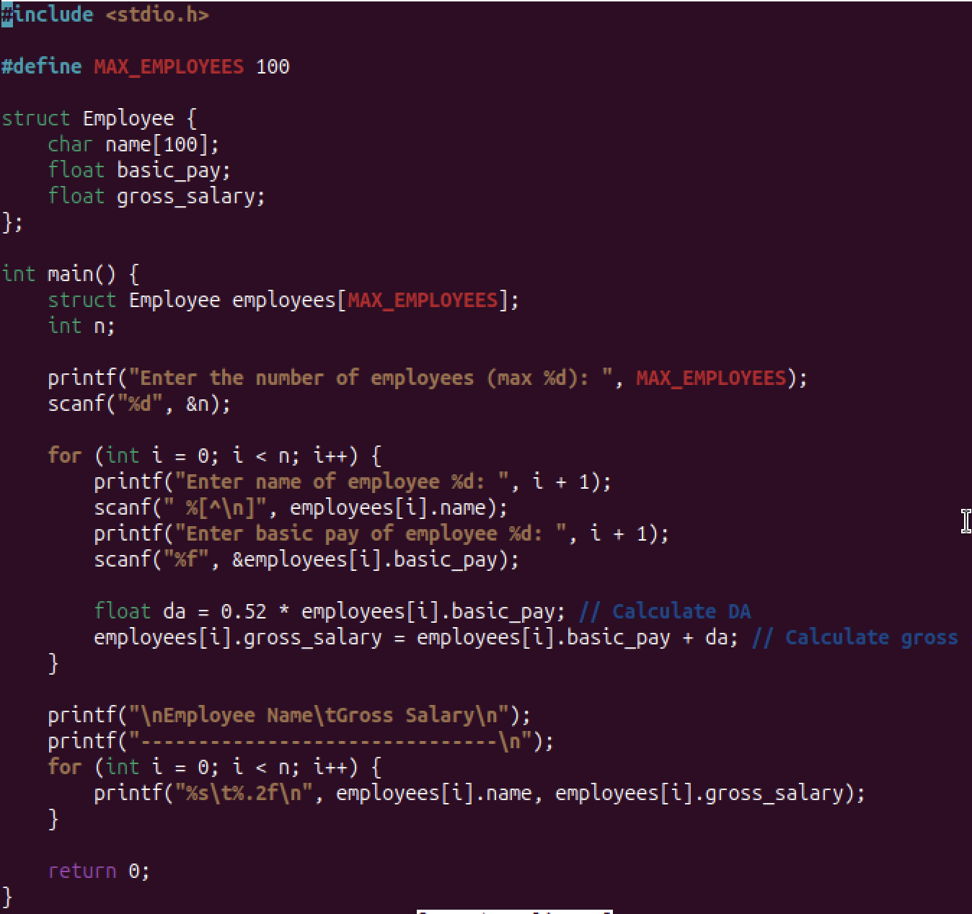

**Output**

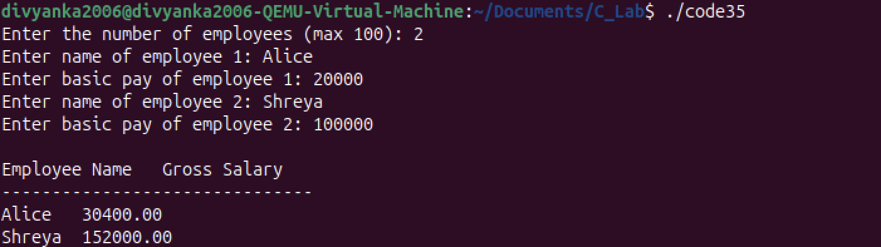

**Explanation**

**Conclusion**

***Thus, the program was successfully executed.***

**Experiment 36**

**Aim**

***Create a Book structure containing book_id, title, author name and price. Write a C program to pass a structure as a function argument and print the book details.***

**Code**

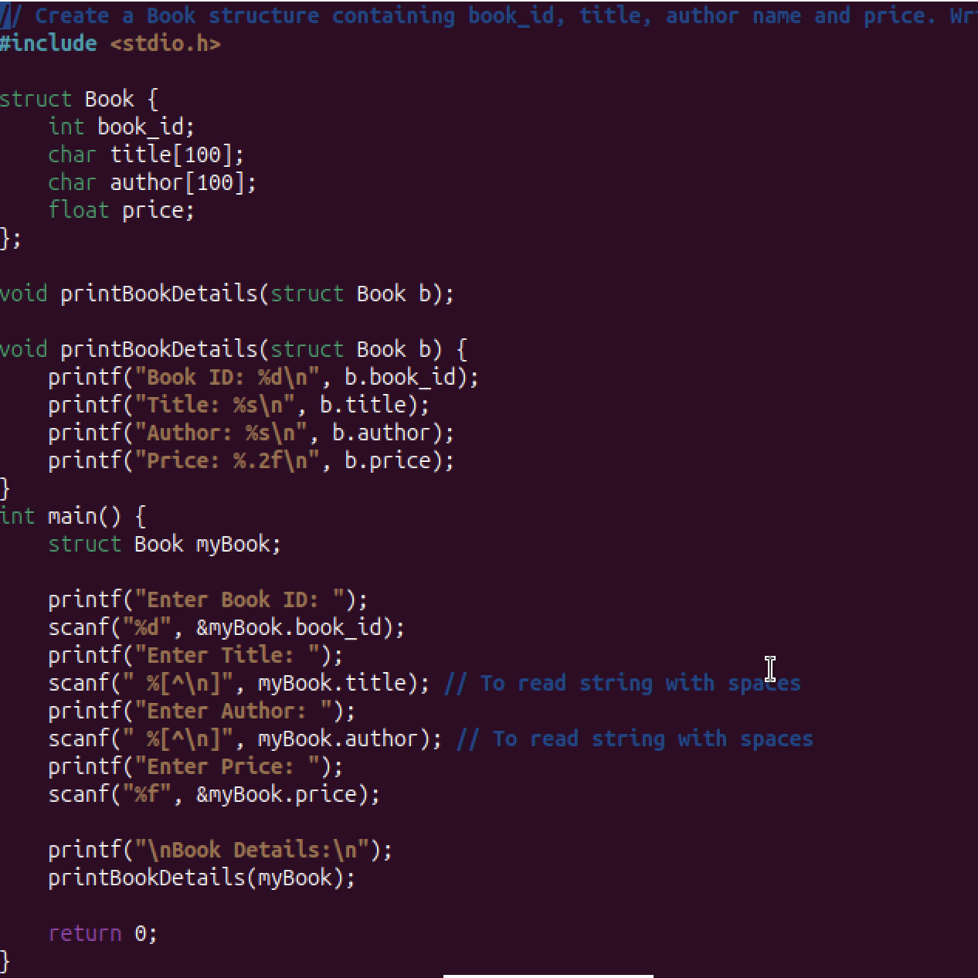

**Output**

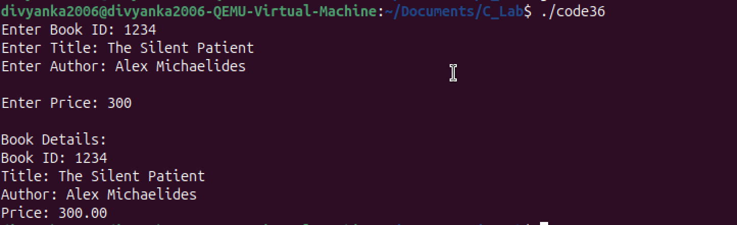

**Explanation**

**Conclusion**

***Thus, the program was successfully executed.***

**Experiment 37**

**Aim**

***Create a union containing 6 strings: name, home_address, hostel_address, city, state and zip. Write a C program to display your present address.***

**Code**

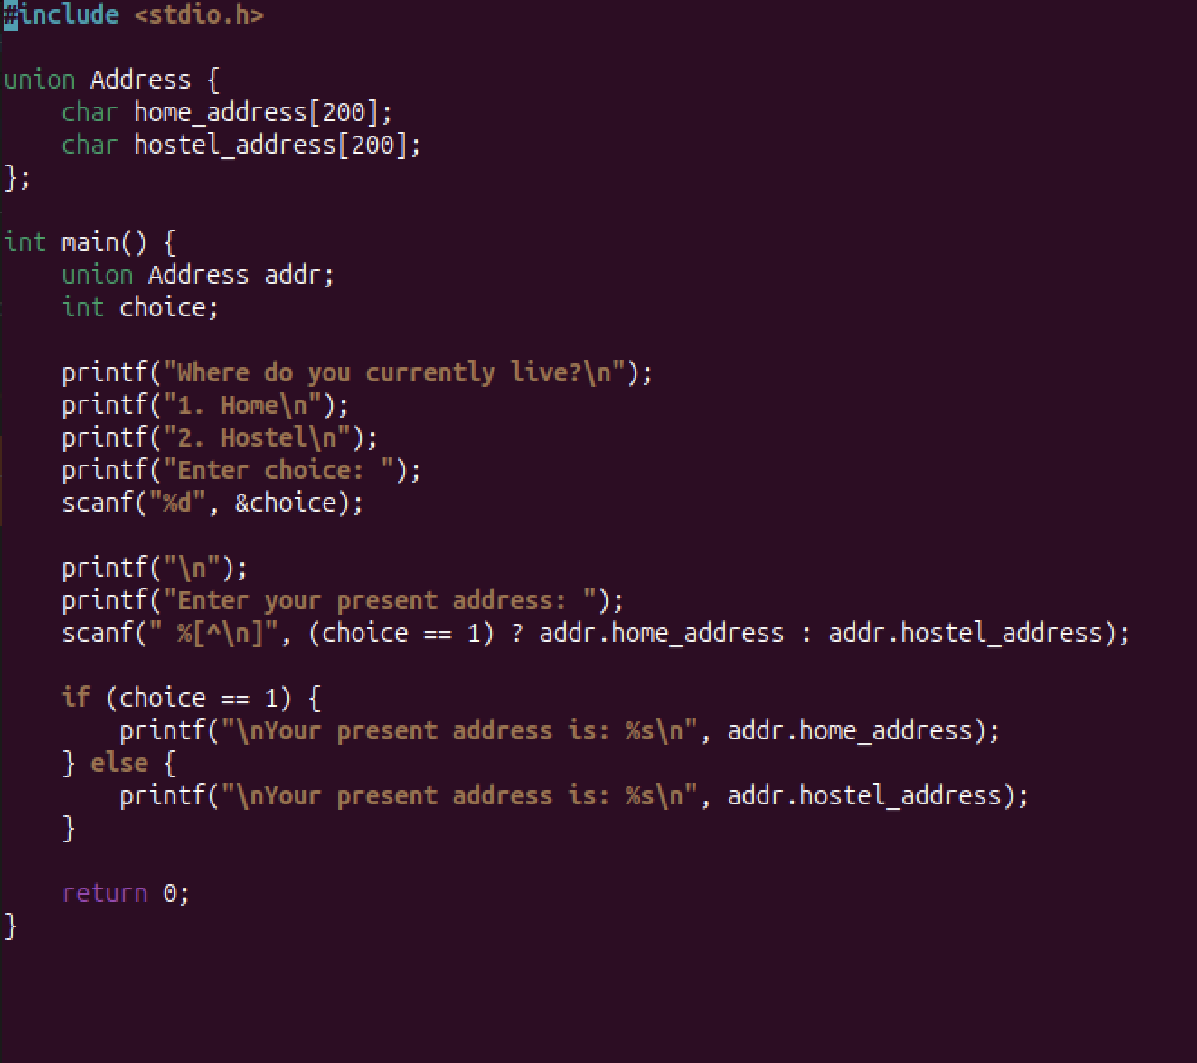

**Output**

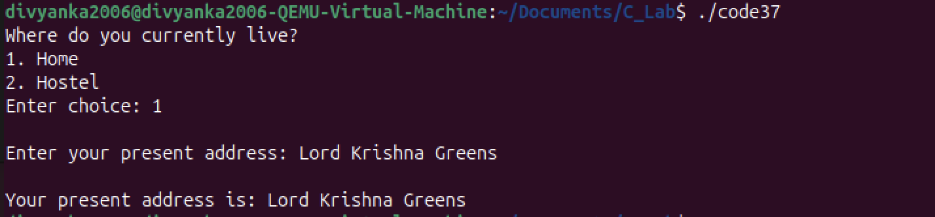

**Explanation**

**Conclusion**

***Thus, the program was successfully executed.***

**Experiment 38**

**Aim**

***WAP that reads two matrices A (m x n) and B (p x q) and computes the product A and B. Read matrix A and matrix B in row major order respectively. Print both the input matrices and resultant matrix with suitable headings and output should be in matrix format only. Program must check the compatibility of orders of the matrices for multiplication. Report appropriate message in case of incompatibility.***

**Code**

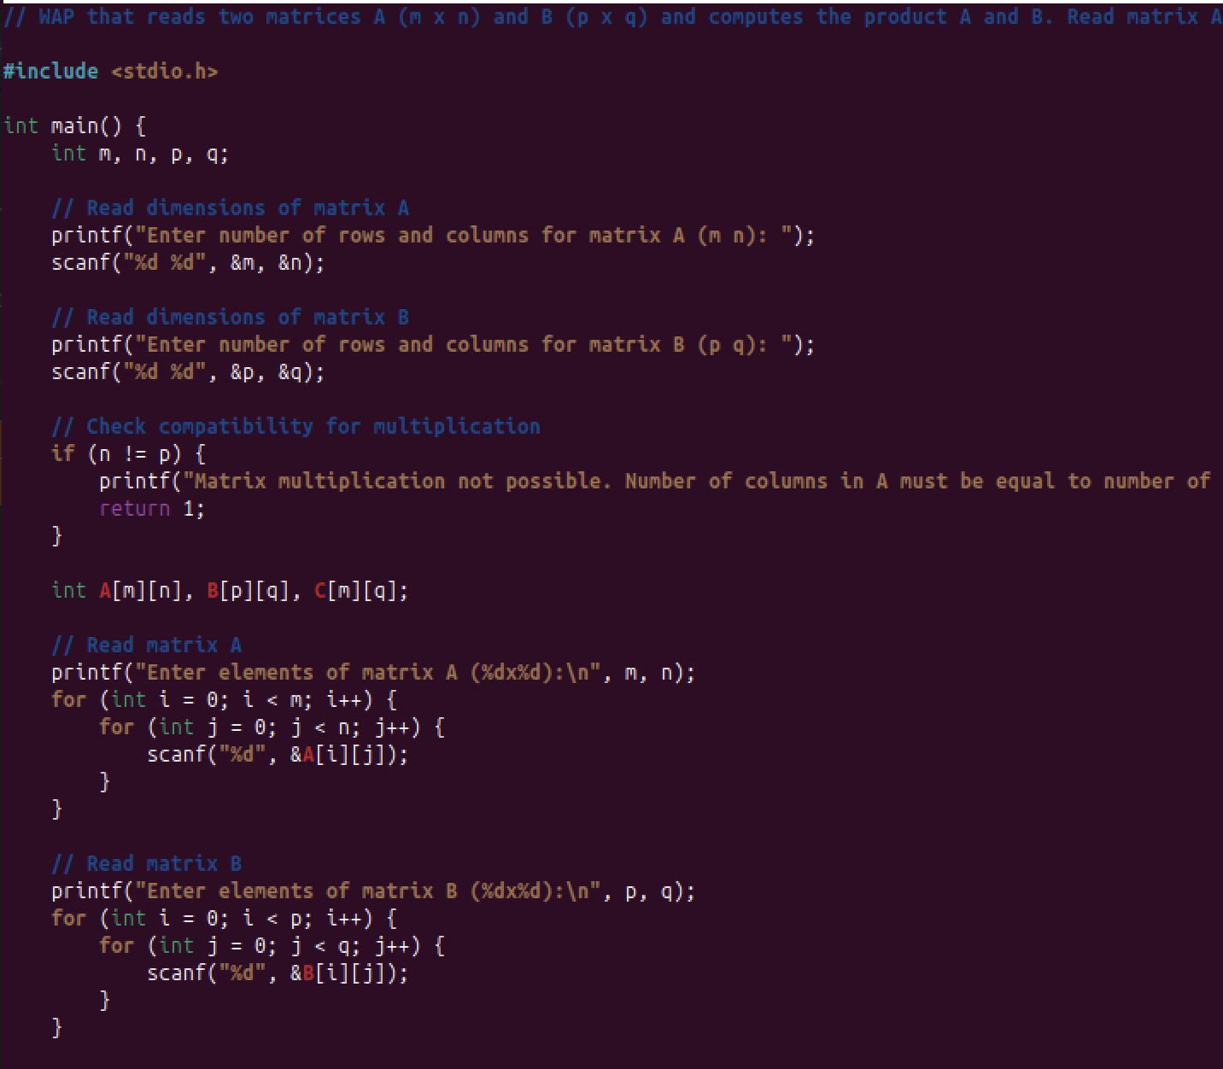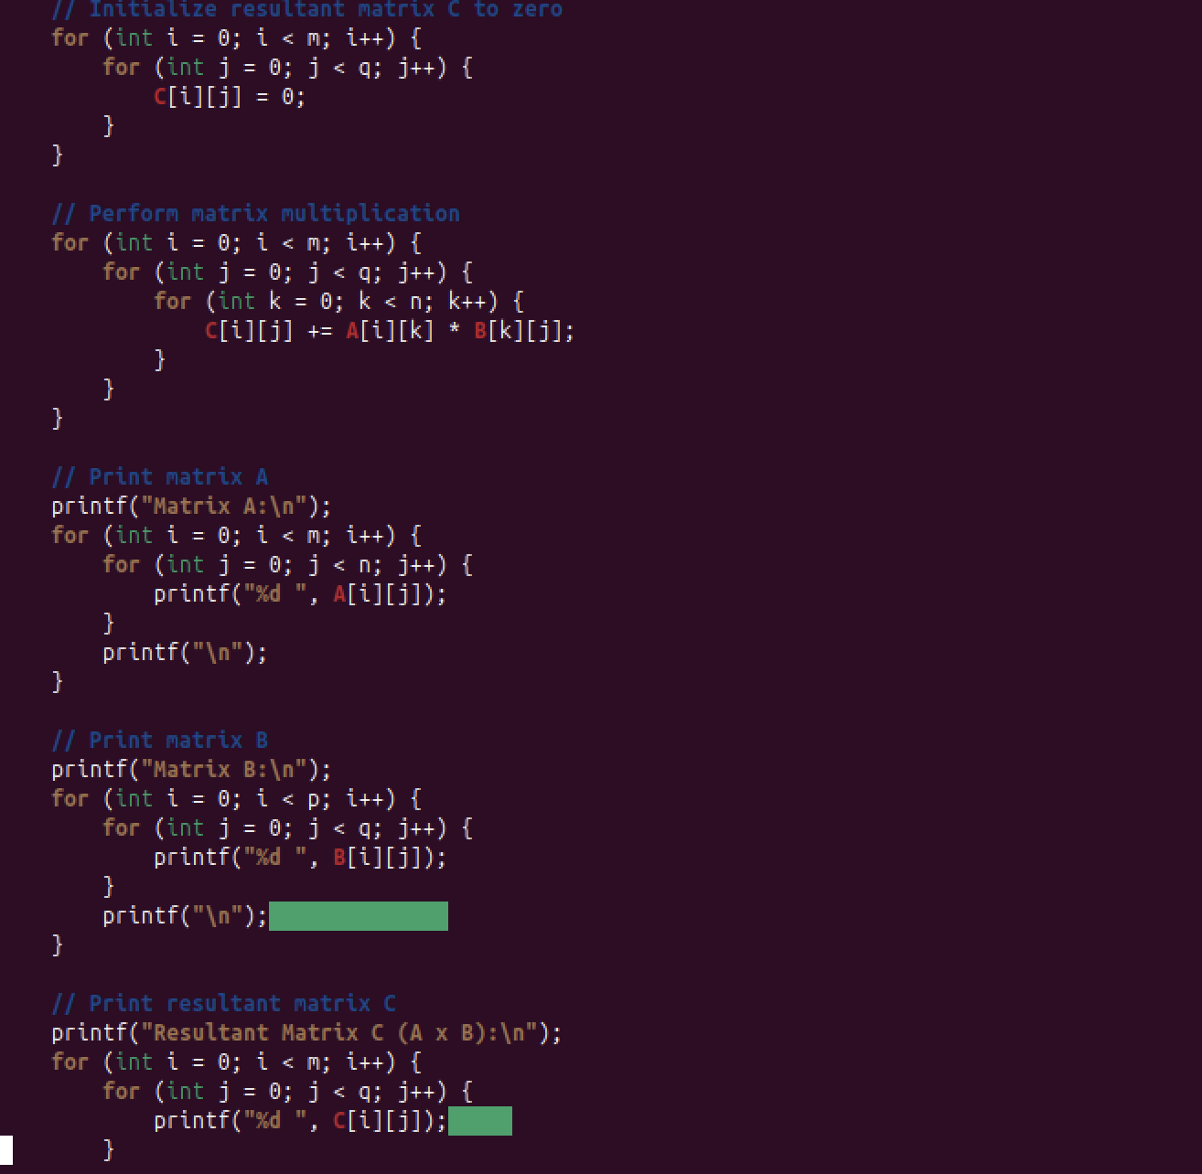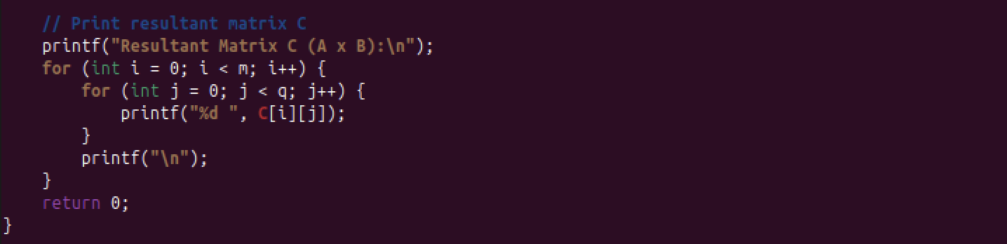

**Output**

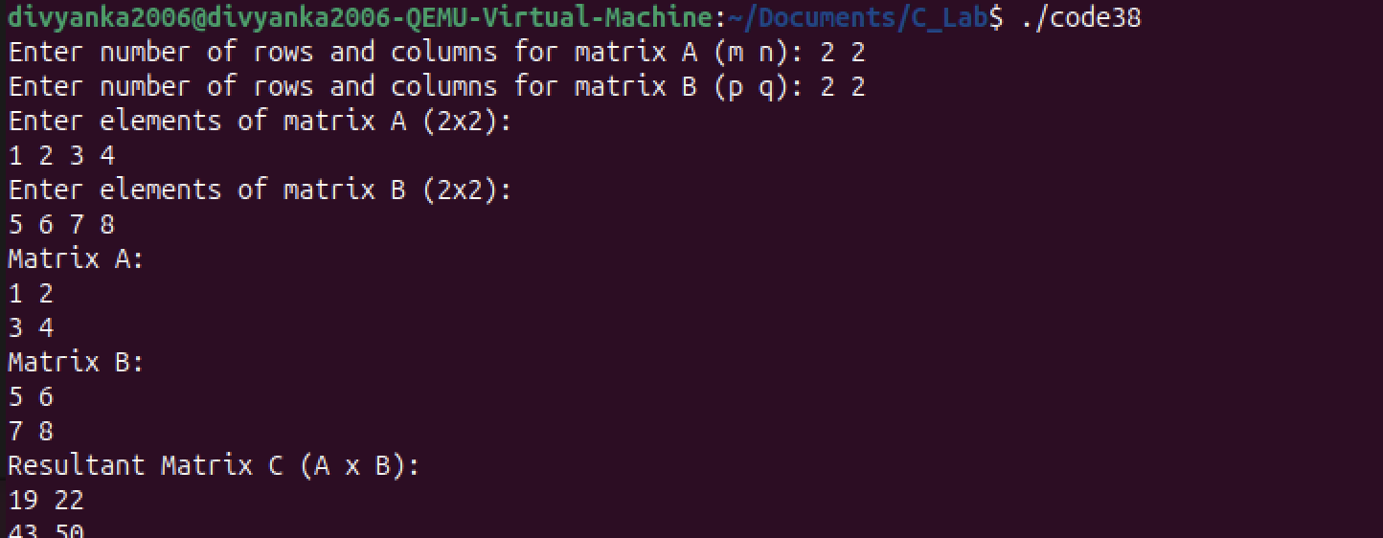

**Explanation**

**Conclusion**

***Thus, the program was successfully executed.***

**Experiment 39**

**Aim**

***Write a C program to compute the monthly pay of 100 employees using each employee‗s name, basic pay. The DA is computed as 52% of the basic pay. Gross-salary (basic pay + DA). Print the employees name and gross salary.***

**Code**

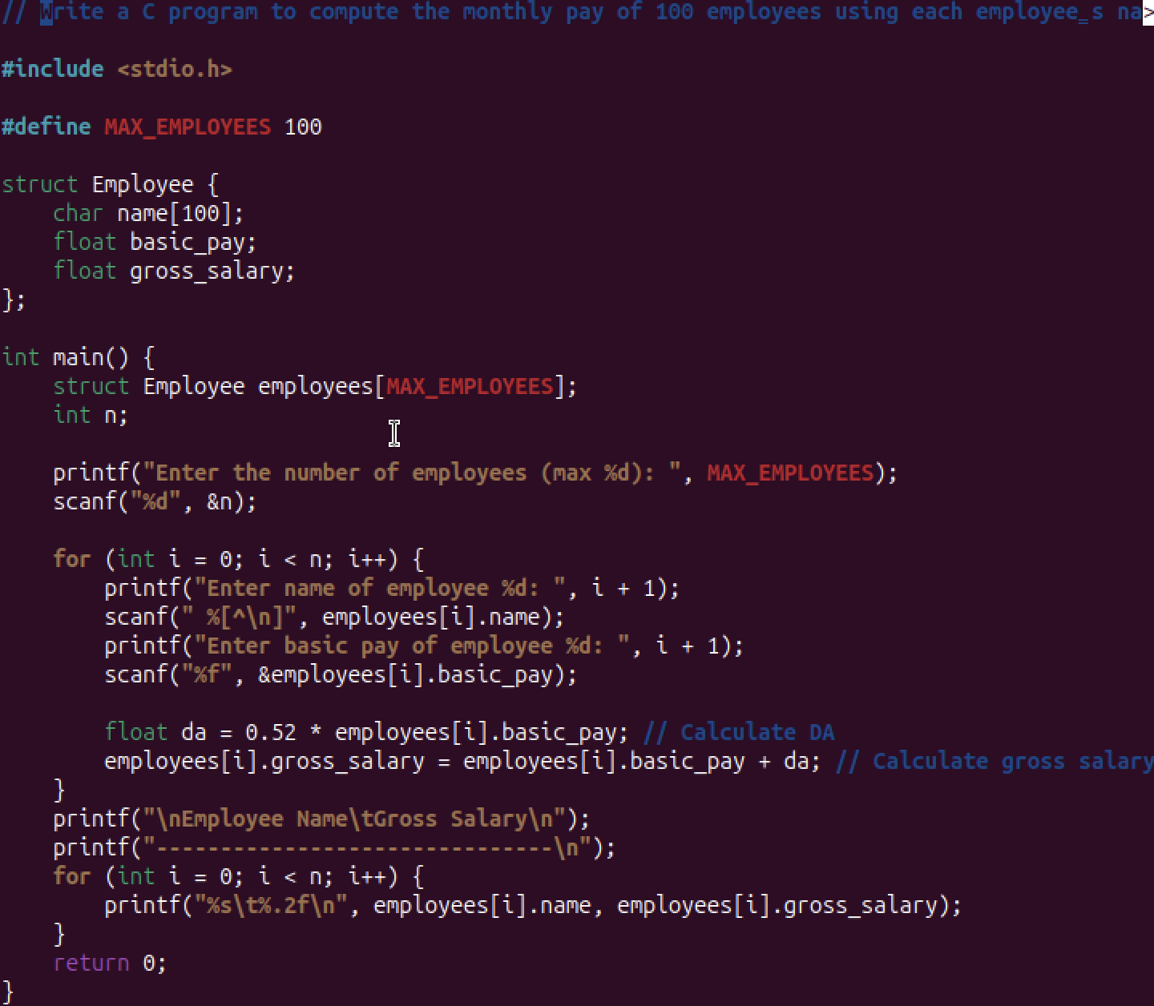

**Output**

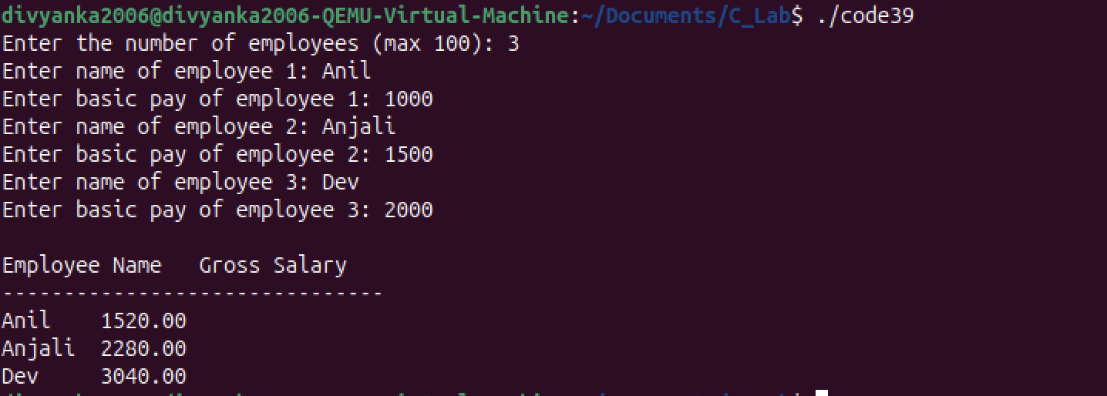

**Explanation**

**Conclusion**

***Thus, the program was successfully executed.***

**Experiment 41**

**Aim**

***Declare different types of pointers (int, float, char) and initialize them with the addresses of variables. Print the values of both the pointers and the variables they point to.***

**Code**

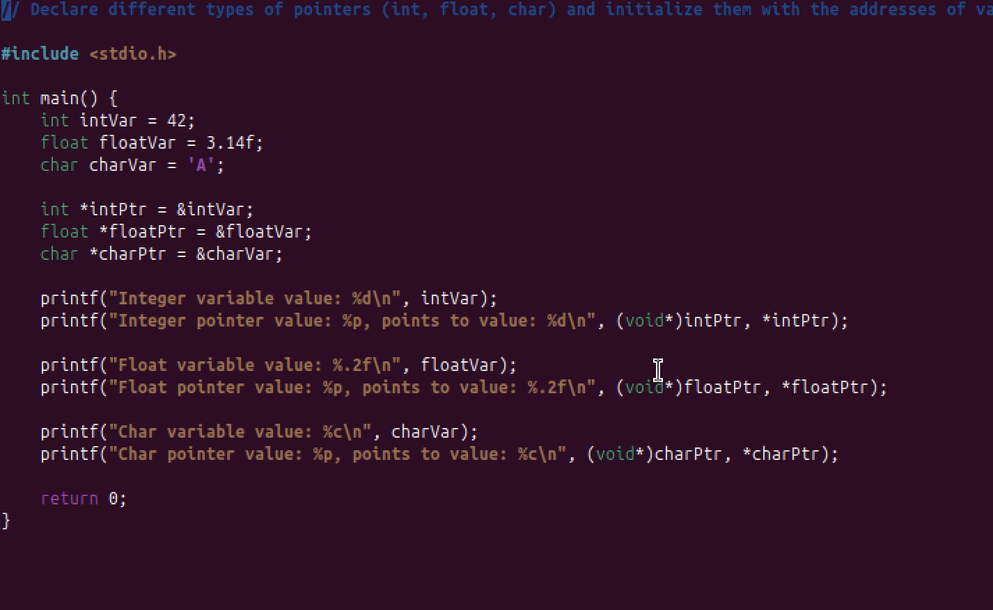

**Output**

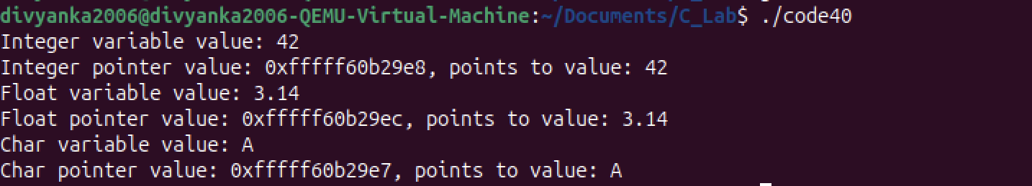

**Explanation**

**Conclusion**

***Thus, the program was successfully executed.***

**Experiment 42**

**Aim**

***Perform pointer arithmetic (increment and decrement) on pointers of different data types. Observe how the memory addresses change and the effects on data access.***

**Code**

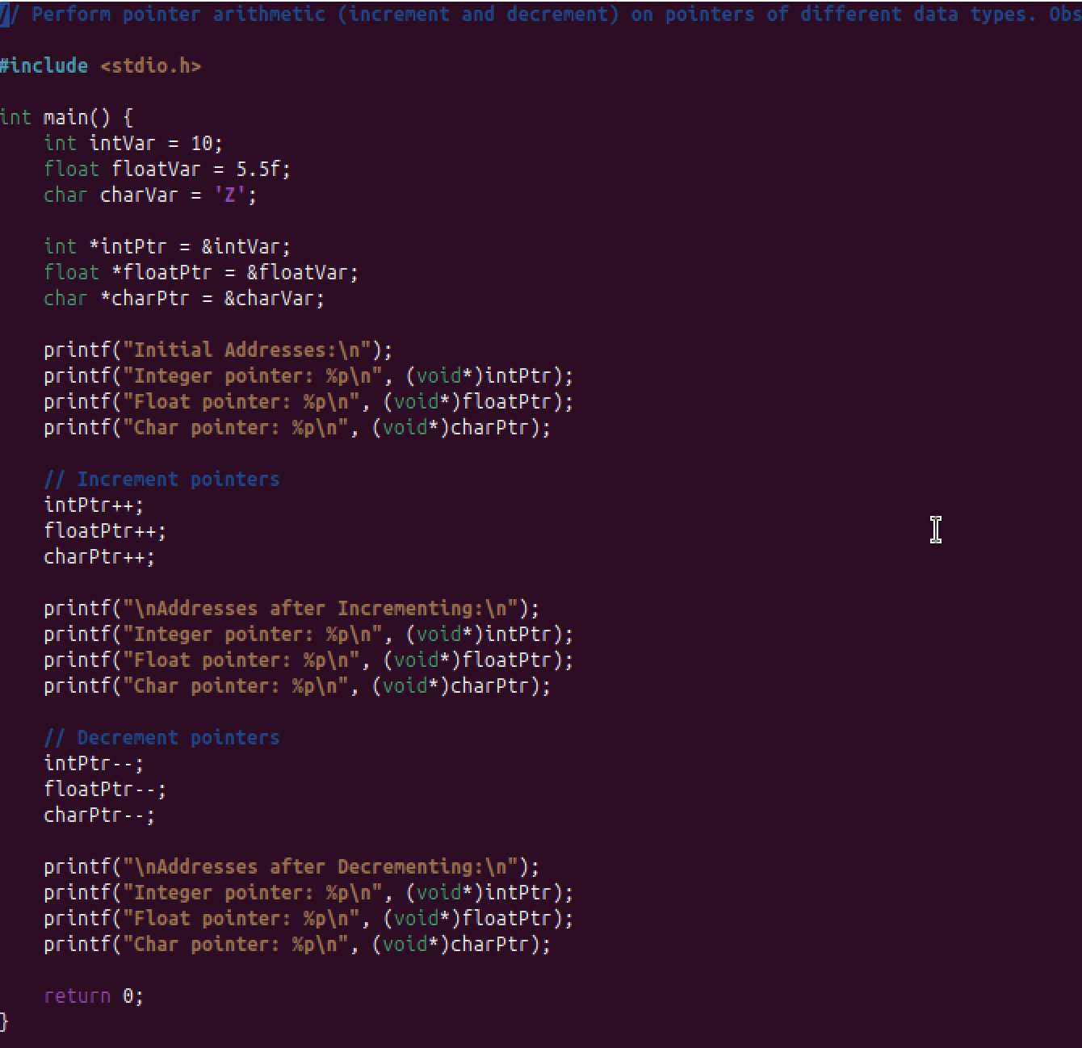

**Output**

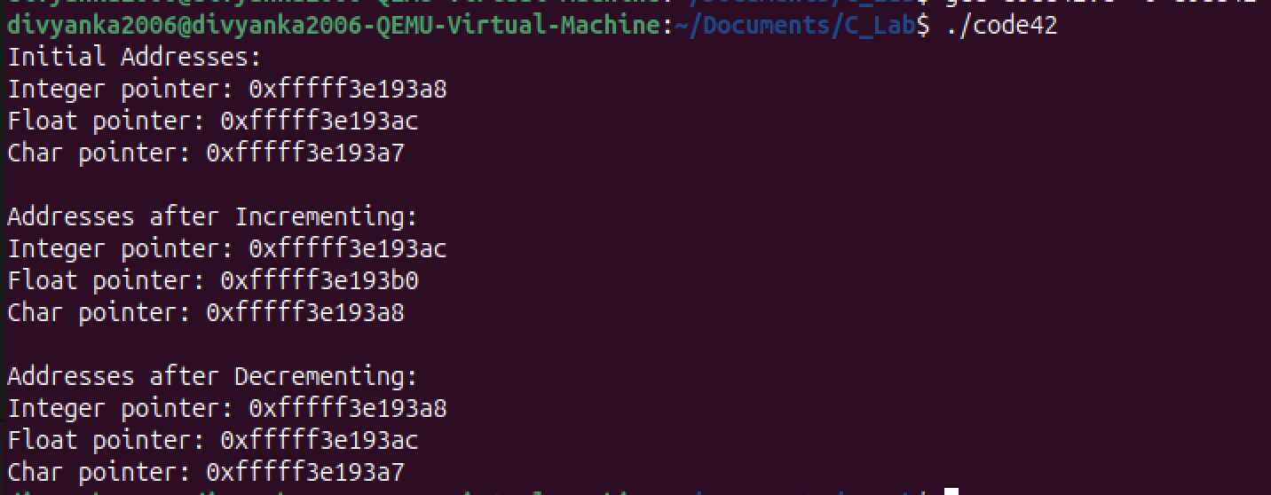

**Explanation**

**Conclusion**

***Thus, the program was successfully executed.***

**Experiment 43**

**Aim**

***Write a function that accepts pointers as parameters. Pass variables by reference using pointers and modify their values within the function.***

**Code**

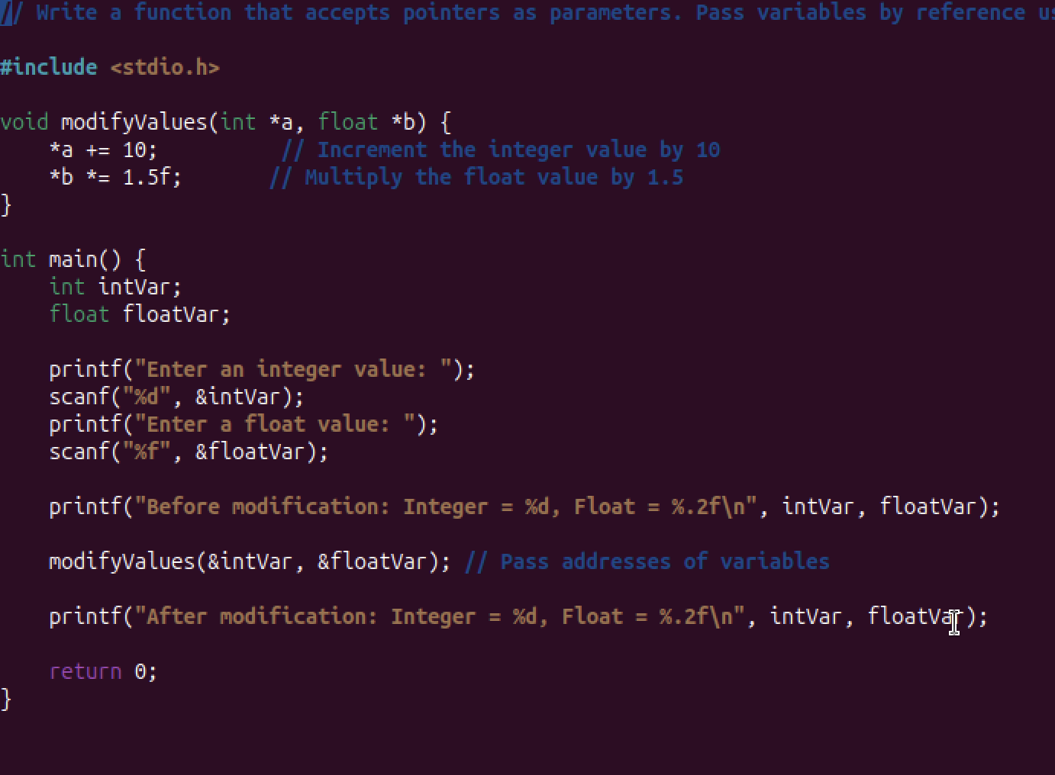

**Output**

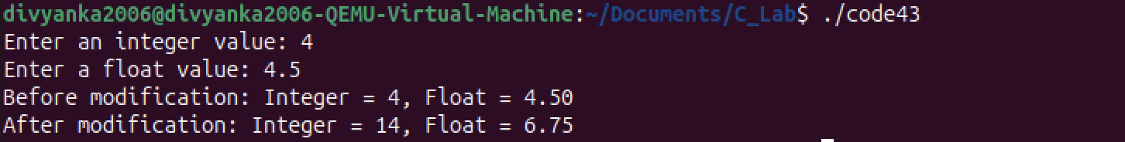

**Explanation**

**Conclusion**

***Thus, the program was successfully executed.***